Name

Mathematics Extension 1 Year 12
Further Calculus Skills

Book 1 | Further derivatives of functions  Techniques of integration | Version: 261002  Feedback:  https://MrDingMaths.com
Contents
Syllabus Content 2
Learning Intention 3

Syllabus Content
MA5-GEO-C-01 identifies and applies the properties of similar figures and scale drawings to solve problems
Identify and describe the properties of similar figures
- Describe similar figures as having the same shape but not necessarily the same size
- Verify and explain that in similar polygons, the corresponding angles are equal and the corresponding side lengths are in the same proportion
- Name the vertices in matching order when using the similar symbol (~) in a similarity statement
- Match the corresponding sides and angles of similar polygons
Solve problems using ratio and scale factors in similar figures
- Apply an appropriate scale to enlarge or reduce a diagram
- Determine the scale factor for pairs of similar polygons and circles
- Apply knowledge of scale factor to find unknown sides in similar polygons
- Solve problems involving unknown lengths and scale factors of similar figures and related practical problems
- Solve problems involving scale drawings, with or without digital tools

Similarity Statements

- Similarity Statements
- Similar figures have the same shape but different size.
- Corresponding (matching) angles in similar figures are equal.
- The symbol ~ indicates similarity.

- Identify the corresponding vertices.
- Write vertices in corresponding order.

- Example Write a similarity statement
E
F
H
G
A
B
C
D

$AB\sim EF$ $∠BAD=∠FEH$
$BC\sim FG$ $∠ABC=∠EFG$
$DC\sim HG$ $∠BCD=∠FGH$
$AD\sim EH$ $∠ADC=∠EHG$

$$∴ABCD\sim EFGH$$

- Guided Practice
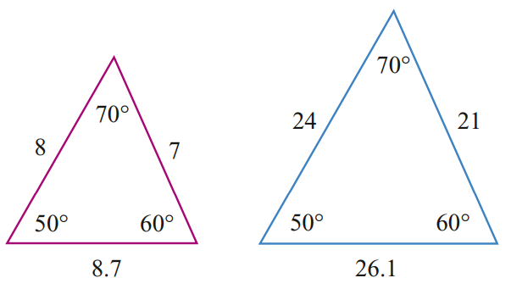
$$N$$
$$O$$
$$P$$
$$L$$
$$K$$
$$M$$

$LK\sim$ $∠LKM=$
$KM\sim$ $∠KML=$
$ML\sim$ $∠MLK=$
$$∴LKM\sim$$
$$LKM\sim NOP$$

- Key Ideas
- If two figures are similar, then they are the exact same …………, but not the same ………
- When writing similarity statements, the vertices must be in ………………… order.

Foundation
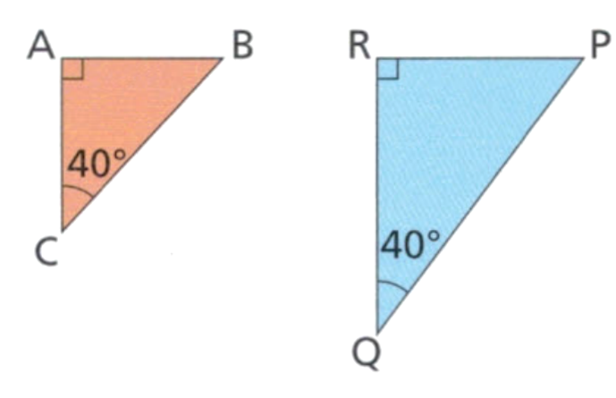
- Identify the corresponding sides and write a similarity statement.

Corresponding angles  $∠CAB$ and $∠QRP$  $∠ABC$ and ………  $$∠RPQ$$  $∠BCA$ and ………  $$∠PQR$$ | Corresponding sides  BC and PQ  AC and ………  RQ  AB and ………  RP

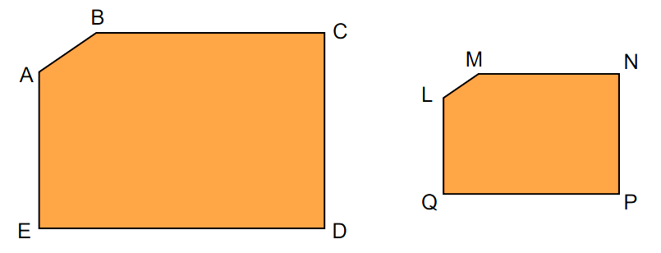
$AB \sim LM$  $BC \sim MN$  $CD \sim$ ……  NP  $ED \sim QP$  $AE \sim$ ……  LQ | $∠ABC =∠LMN$  $∠BCD =∠$……  MNP  $∠CDE =∠$……  NPQ  $∠$ …… $=∠LQP$  AED  $∠$ …… $=∠$……  $$∠EAB=∠QLM$$

$∴ABCDE \sim$ …………
LMNPQ

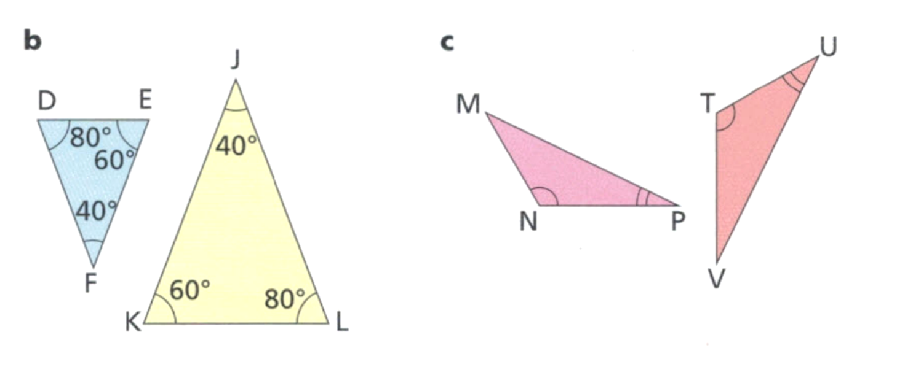
$DE\sim$……  LK  $EF\sim$ ……  KJ  $FD \sim$……  JL | $∠DEF=∠PQR$  $∠EFD =∠$……  $$∠KJL$$  $∠FDE =∠$……  $$∠JLK$$
$∴DEF \sim$ …………
LKJ

MP $\sim$ ……  MP ~ VU  PN $\sim$ ……  PN ~ UV  …. $\sim$ ……  NM ~ TV | $∠MPN$ $=$ ………  $$∠VUT$$  $∠PNM$ $=$ ………  $$∠UTV$$  $∠NMP$ $=$ ………  $$∠TVU$$
$∴$ ……… $\sim$ ………
MPN ~ VUT

Development
- Identify the corresponding sides and write a similarity statement.

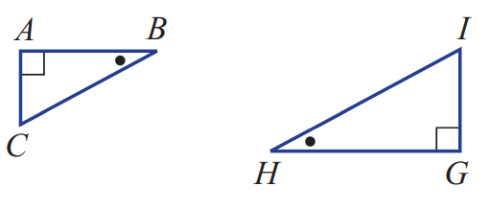
AB$\sim$…… $∠CAB=$ ………
GH $∠IGH$
BC$\sim$…… $∠ABC=$ ………
HI $∠GHI$
CA$\sim$…… $∠BCA=$ ………
IG $∠HIG$
$∴$ ……… $\sim$ ………
ABC ~ GHI

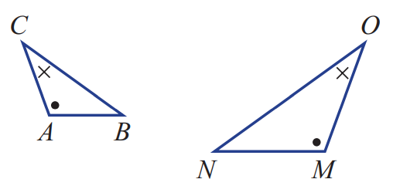
AB$\sim$…… $∠ACB=$ ………
MN $∠MON$
BC$\sim$…… $∠CAB=$ ………
NO $∠OMN$
CA$\sim$…… $∠CBA=$ ………
OM $∠ONM$
$∴$ ……… $\sim$ ………
ABC ~ MNO

  - (Hint: Redraw the diagram as two triangles)
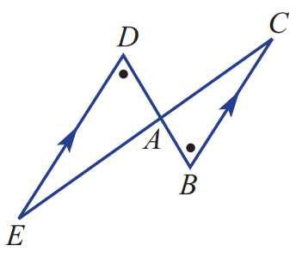

AD$\sim$…… $∠ADE$ $=$ ………
AB $∠ABC$
DE$\sim$…… $∠DEA$ $=$ ………
BC $∠BCA$
EA$\sim$…… $∠EAD$ $=$ ……… $∴$ ……… $\sim$ ………
CA $∠CAB$ ADE ~ ABC

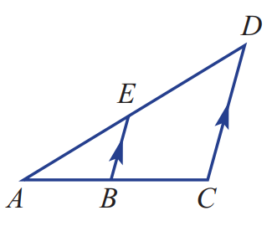
  - (Hint: Redraw the diagram as two triangles)

AB$\sim$…… $∠EAB$ $=$ ………
AC $∠DAC$
AE$\sim$…… $∠EBA$ $=$ ………
AD $∠DCA$
EB$\sim$…… $∠AEB$ $=$ ……… $∴$ ……… $\sim$ ………
DC $∠ADC$ ABE ~ ACD

Determining whether Two Figures are Similar

- Conditions for Similar Figures
Similar figures have:
- equal corresponding angles.
- corresponding sides in the same ratio.

- Determine whether two figures are similar
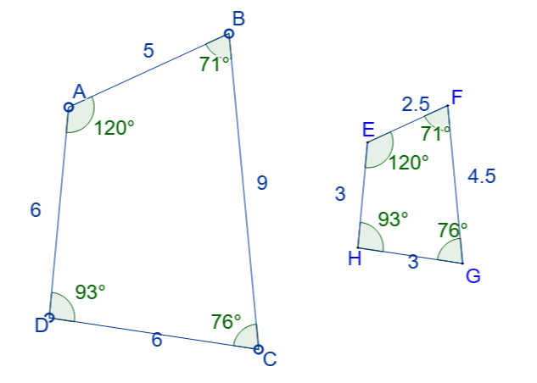
Write down the corresponding sides.

$AB\sim$
$BC\sim$
$CD\sim$
$AD\sim$
Compare the corresponding sides to see
whether they are in the same ratio.
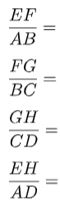

The two figures are similar because corresponding angles are ……………………, and corresponding sides are in the same ……………………

Determine whether these two figures are similar.
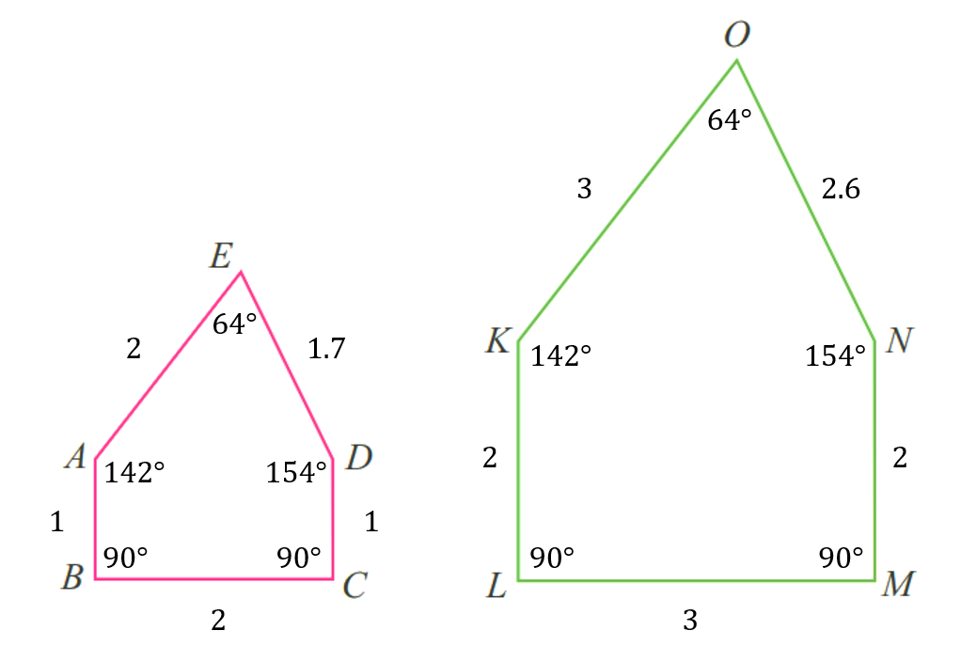
$$\frac{KL}{AB}=$$
$$\frac{LM}{BC}=$$
$$\frac{NM}{DC}=$$
$$\frac{ON}{ED}=$$
$$\frac{OK}{EA}=$$

The two figures are ……………………… because ……………………………………………

Foundation
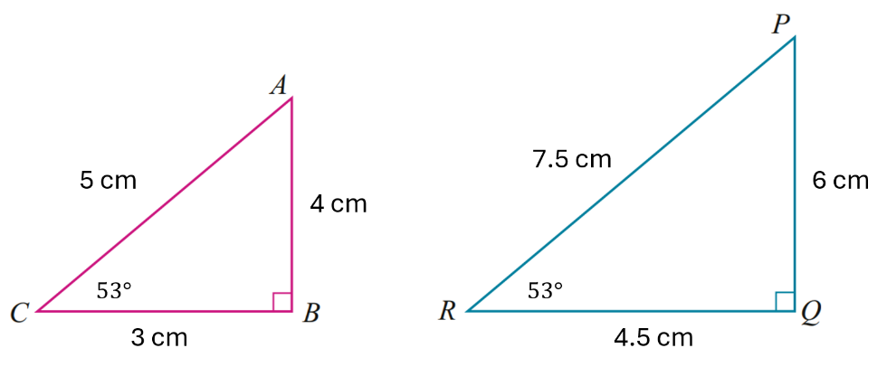
- Look at the following pair of triangles.

  - Find the size of the remaining angle in each of these triangles.
37°
  - Name the angle on the larger triangle that corresponds to:
i $∠ACB$  $$∠PRQ$$ | ii $∠CBA$  $$∠RQP$$ | iii $∠BAC$  $$∠QPR$$
  - Are the corresponding angles equal? ………………
yes
  - Name the side on the larger triangle that corresponds to:
i $BC$  QR | ii $AB$  PQ | iii $AC$  PR
  - Find the ratios of the sides.
i $\frac{QR}{BC}$ $=$  1.5 | ii $\frac{PQ}{AB}$ $=$  1.5 | iii $\frac{PR}{AC}$ $=$  1.5
  - Therefore, explain why the two triangles are similar.
Corresponding angles are equal. Corresponding sides are in the same ratio.
- Consider these two triangles.
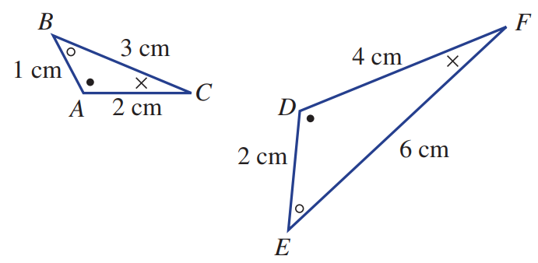

  - Name the angle on the larger triangle that corresponds to:
i $∠BAC$  $$∠EDF$$ | ii $∠ABC$  $$∠DEF$$ | iii $∠BCA$  $$∠EFD$$
  - Name the side on the larger triangle that corresponds to:
i $AB$  DE | ii $BC$  EF | iii $CA$  FD
  - Find the ratios of the sides.
i $\frac{DE}{AB}$ $=$  2 | ii $\frac{EF}{BC}$ $=$  2 | iii $\frac{FD}{CA}$ $=$  2
  - Therefore, explain why the two triangles are similar.
Corresponding angles are equal. Corresponding sides are in the same ratio.

Development
- Decide whether these pairs of rectangles are similar by checking if corresponding sides are in equal ratio.
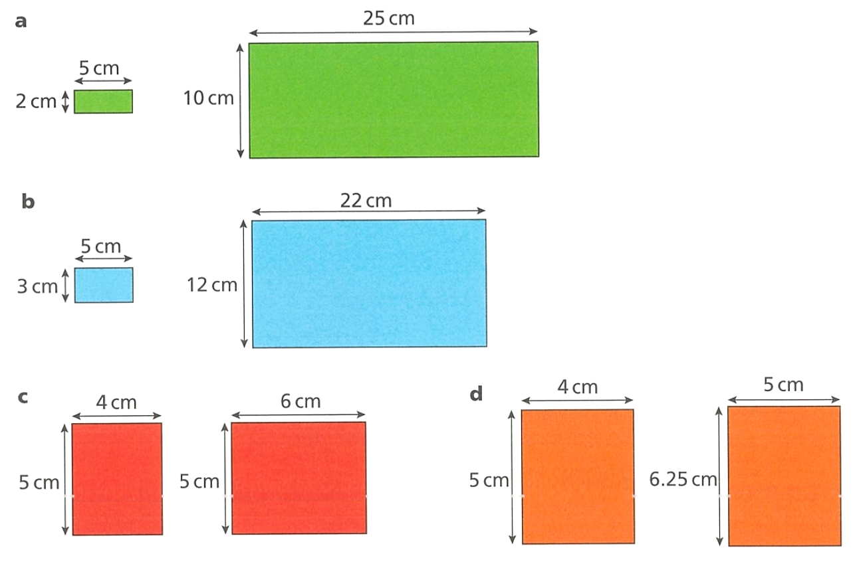  $\frac{25}{5}=$ $\frac{10}{2}=$  yes | no
no | yes

- Why aren’t all rectangles similar?
Although all rectangles always have the same a…………………, their side lengths are not always in the same r…………………
Angles, ratio
- Decide whether these shapes are similar. Remember that two shapes are similar if:
- All corresponding angles equal.
- All corresponding sides in equal ratio.
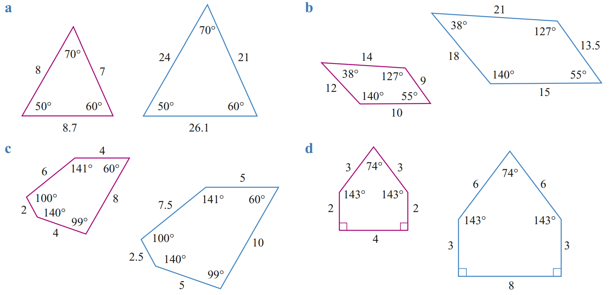  All angles the same? Yes | No  yes  All sides in equal ratio? Yes | No  $$\frac{21}{7}=3 \frac{24}{8}=3 \frac{26.1}{8.7}=3$$  yes  Similar? Yes | No  yes | All angles the same? Yes | No  yes  All sides in equal ratio? Yes | No  yes  Similar? Yes | No  yes
All angles equal, all corresponding sides in same ratio of 1.25  Yes, similar | All angles equal, not all sides in same ratio  Not similar
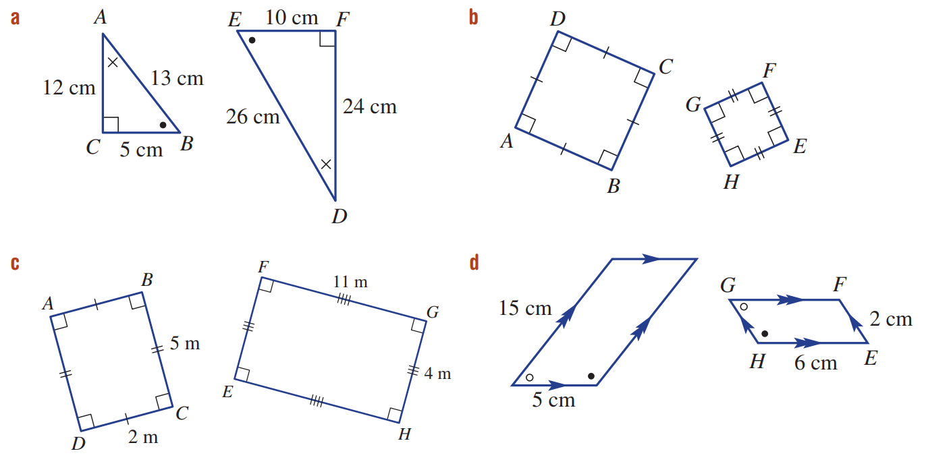  All angles equal, all corresponding sides in same ratio of 2  Yes, similar | Yes, all squares are similar
All angles equal, not all sides in same ratio  Not similar | All angles equal, all corresponding sides in same ratio of 2.5  Yes, similar

Mastery
- These statements are correct. Provide justification.
  - All squares are similar.

All angles are equal at 90°
If one side is multiplied by some factor $k$, then all sides must be multiplied by some factor $k$ as a square has all equal sides.
Therefore, all sides would be in the same ratio. So, similar.
  - All equilateral triangles are similar.

All angles are equal at 60°
If one side is multiplied by some factor $k$, then all sides must be multiplied by some factor $k$ as an equilateral triangle has all equal sides.
Therefore, all sides would be in the same ratio. So, similar.
- Here are two rectangles, A and B, drawn on a square grid.
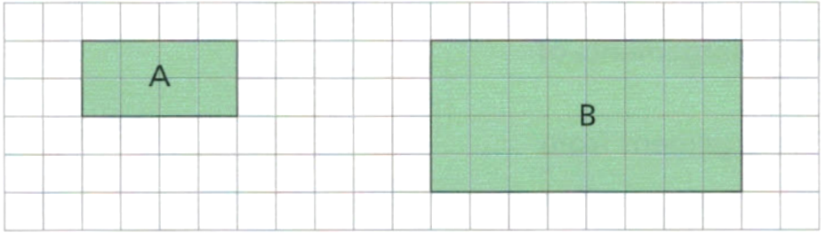

  - Explain why rectangle B is similar to rectangle A

Each side has been doubled, so they are in the same ratio.
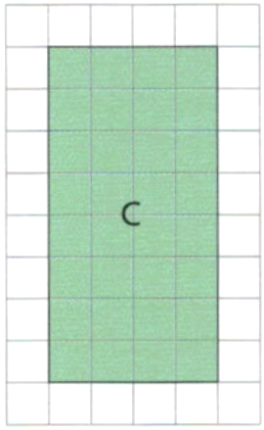
  - Here is a third rectangle, C.
Is rectangle C similar to rectangle A? Explain your answer.

Yes, this is rectangle B but rotated.
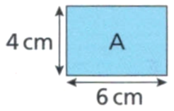
- Here is rectangle A.

Which of these rectangles are similar to rectangle A?
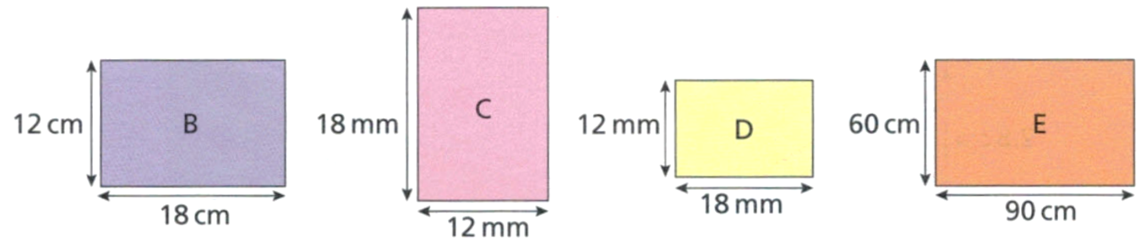

All of them
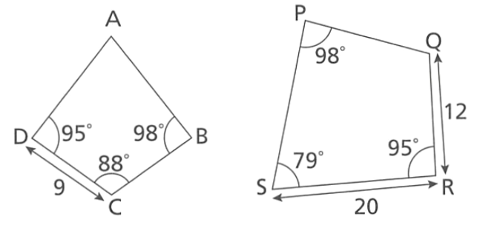
  - Find the missing angles in the quadrilaterals.
  - Explain why you can’t say for certain these two quadrilaterals are similar.

The missing angles are 79° and 88°
The two shapes don’t have the same angles, so they cannot be similar.

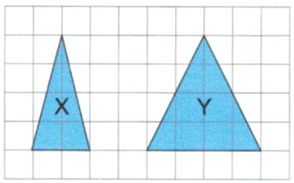
- Here are two triangles, X and Y.
Explain why triangle X is not similar to triangle Y.

No, the base has been doubled but the height has not been doubled.

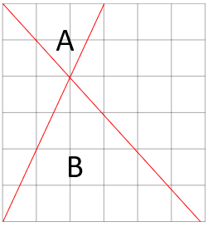
- Whitney says triangle A and B are similar. Do you agree? Why?

Yes, B has double the base and double the height of A.
- Are all circles similar?

Yes.

Enlarge and Reduce Diagrams

- Scale Factor
- Similar figures have corresponding sides in the same ratio.
- This ratio is called the scale factor, $k$.
- The scale factor is the number you multiply the original shape by to get the image.
Reduction | Congruent | Enlargement
$k$ < 1  the image is smaller than the original. | $k$ = 1  the image is identical, or congruent, to the original. | $k$ > 1  the image is larger than the original.
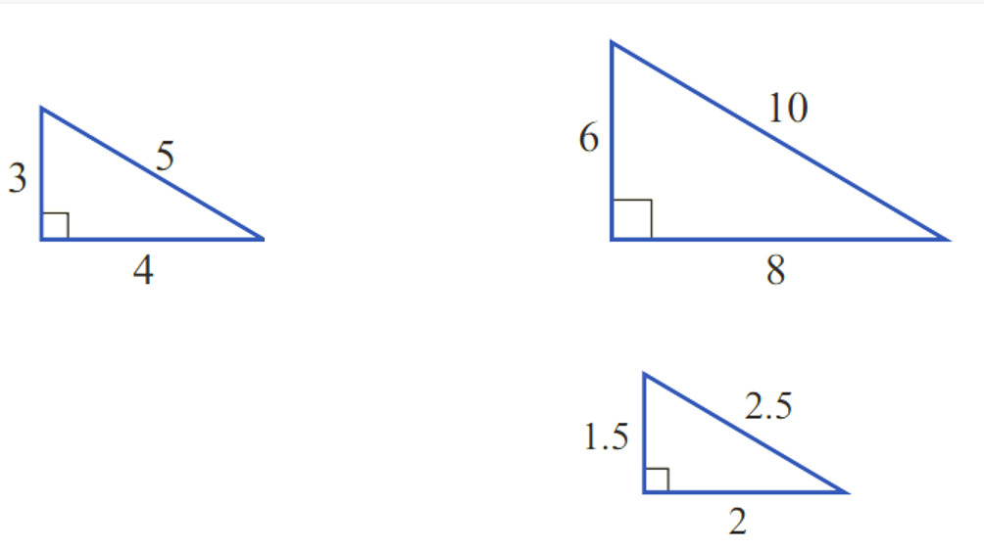
Scale factor
0.5
Scale factor
2

- Example Enlarge and reduce diagrams
Worked Example | Your Turn
Enlarge this shape by a scale factor of 2. | Reduce this shape by a factor of 0.5.

- Key Ideas
- A scale factor of $k$ means to ………………… every side of the original shape by $k$ to get the lengths of the image.

Foundation
- Enlarge or reduce these given diagrams by the scale factor.
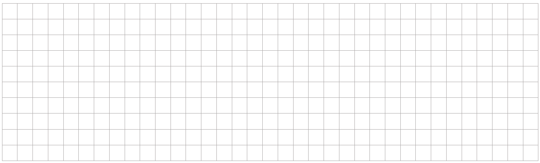
  - Scale Factor: 3

  - Scale Factor: 1.5

  - Scale Factor: 0.5

  - Scale Factor: $\frac{1}{3}$

  - Scale Factor: 3.5

  - Scale Factor: 0.25

  - Scale Factor: 1

  - Scale Factor: $\frac{1}{4}$

Calculating Unknown Side Length

- Finding Image Length and Original Length
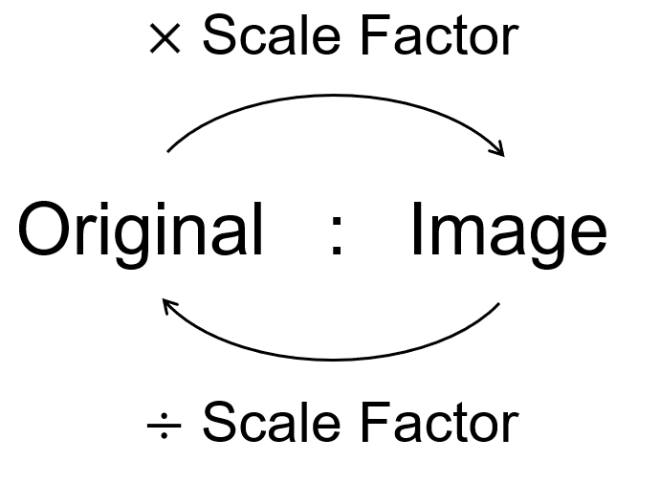
For corresponding sides
in similar figures:

- Example Success Criteria
The scale factor is 4.  Calculate the sides of the image.  Original Image  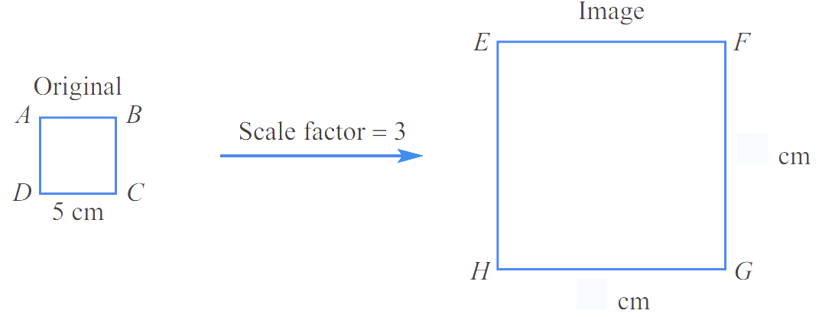  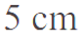  $$20$$  $$20$$  $$×4$$ | The scale factor is 2.  Calculate the sides of the original.  Original Image  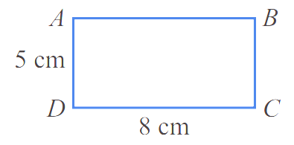  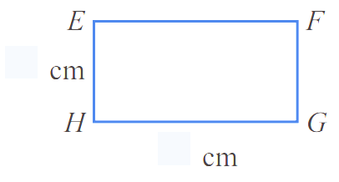  $$2.5$$  $$4$$  $$÷2$$

- Guided Practice
Calculate the unknown sides.
- The scale factor is 2  Original Image  10  10 | - The scale factor is 5  Original Image  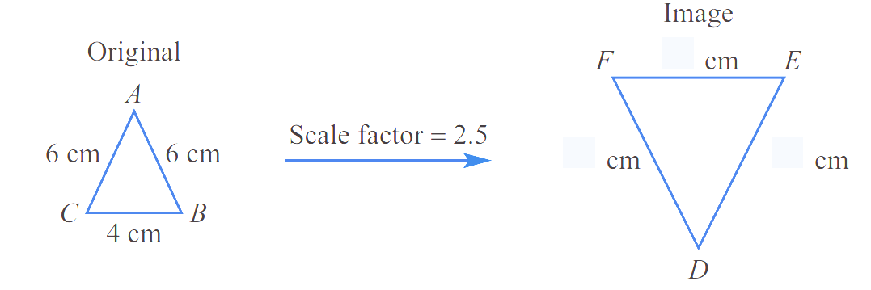  20  30  30
- The scale factor is 2.5  Original Image  15  15  10 | - The scale factor is 0.5  Original Image  10  16

Foundation
- Calculate the missing dimensions.
- The scale factor is 2.  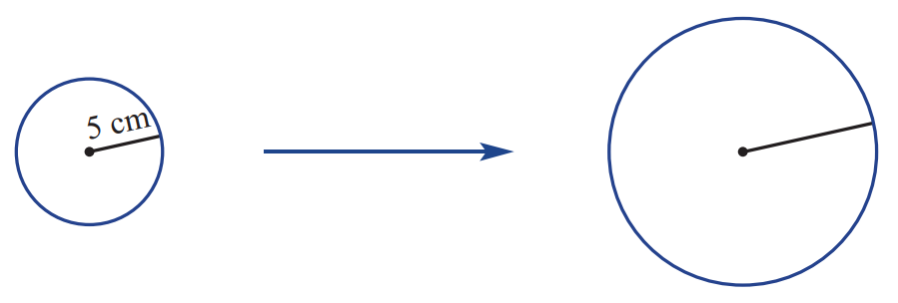  10 cm | 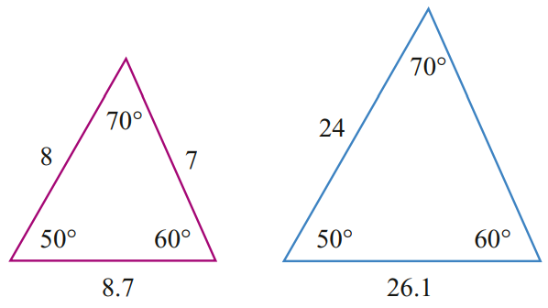  - The scale factor is 3.  21
- The scale factor is 1.5.  4, 4, $5.\dot{3}$ | 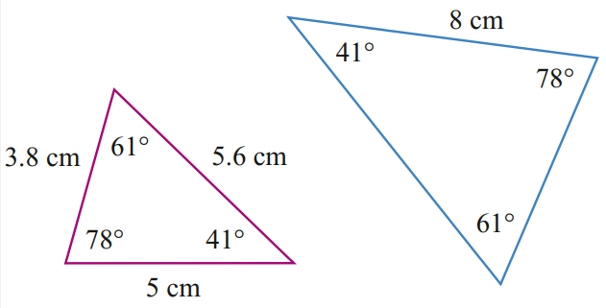  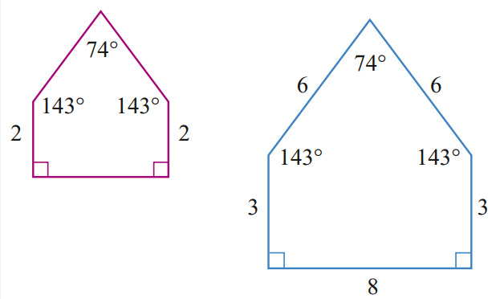  - The scale factor is 1.6.  8.96, 6.08

- A photo of a sun-flower is enlarged by a scale factor of 2.
If the larger flower has a diameter of 7.4 cm, what is the diameter of the smaller flower?

3.7 cm

- A regular hexagon has been enlarged by scale factor 4. The image has a perimeter of 36 cm. What is the length of each side of the original hexagon?

1.5 cm

Calculating Scale Factor

- Scale Factor
$$Scale Factor= \frac{Length of Image}{Length of Original}$$
- Identify a pair of corresponding sides.
- Calculate scale factor.

- Example Determine scale factor
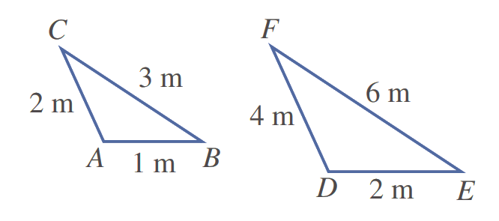  Original Image  1. $CB$ and $FE$ are matching sides.  2. $Scale Factor=$ $\frac{Image}{Original}$ $=$ $\frac{FE}{CB}$ $=$ $\frac{6}{3}$ $=2$ | 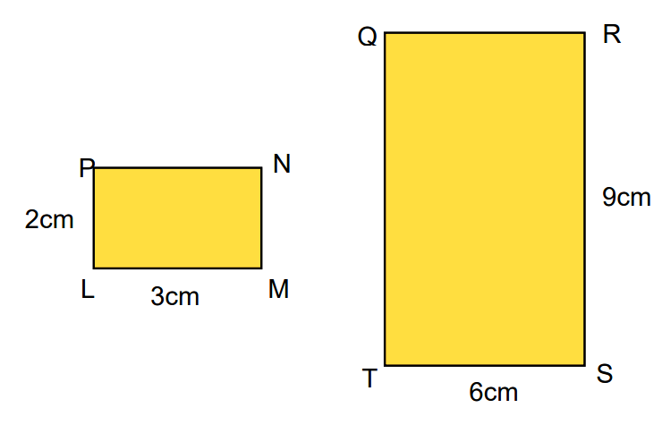  Original Image  1. $RS$ and $LM$ are matching sides.  2. $Scale Factor=$ $\frac{Image}{Original}$  $=$ $\frac{LM}{RS}$ $=$ $\frac{3}{9}$ $=$ $\frac{1}{3}$
- Guided Practice
Determine the scale factor:
- Original length: 6 cm  Image length: 3 cm  $$Scale Factor= \frac{Image}{Original}=$$  $$\frac{1}{2}$$ | - Original length: 51 cm  Image length: 7 cm  $$\frac{7}{51}$$
- Original Image  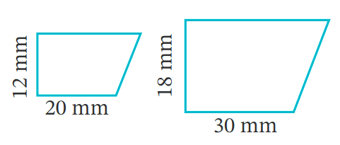  1.5 | - Original Image  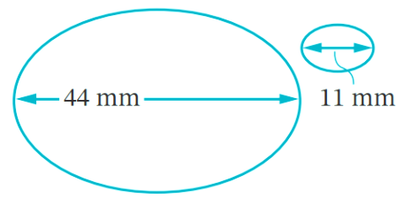  $$\frac{1}{4}$$

- Key Ideas
- Calculate scale factor by ……………… the image length by the original length for a pair of ……………………… sides.

Foundation
- Calculate the scale factor for these similar figures.
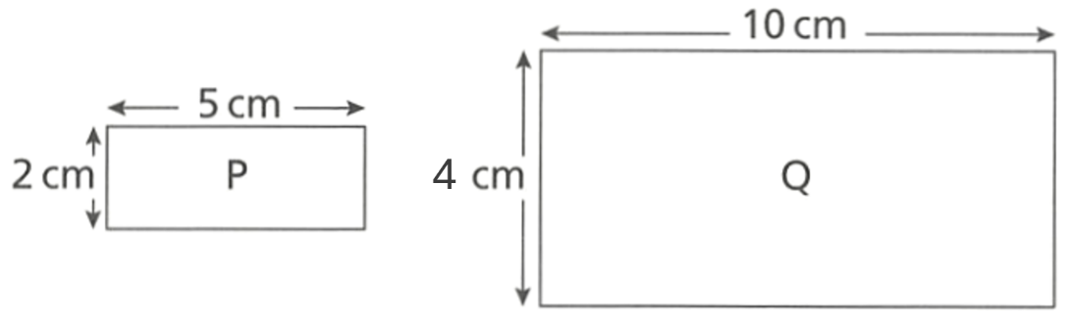  - Original Image  $$Scale Factor= \frac{Image}{Original}=$$  2 | - Original Image  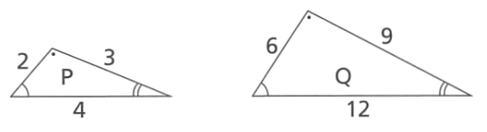  3
- Original Image  $$\frac{1}{3}$$ | - Original Image  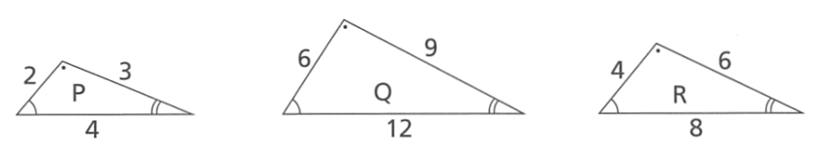  $$\frac{3}{2}$$
- Original Image  $$\frac{1}{2}$$ | - Original Image  $$\frac{2}{3}$$
- The two figures below are similar.
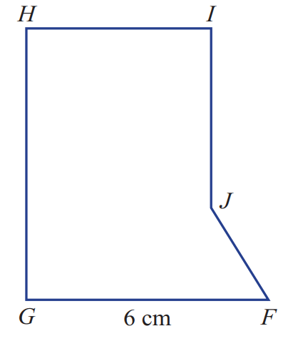
Original Image

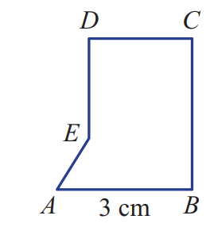

  - Name the angle in the larger figure that matches to $∠A$.
$$∠F$$
  - Name the angle in the smaller figure that matches to $∠I$.
$$∠D$$
  - Name the side in the larger figure that matches to $BC$.
GH
  - Name the side in the smaller figure that matches to $FJ$.
AE
  - Use $FG$ and $AB$ to find the scale factor.
2

Development
- Write a similarity statement for these triangles and calculate the scale factor.
Treat the blue triangle as the image.
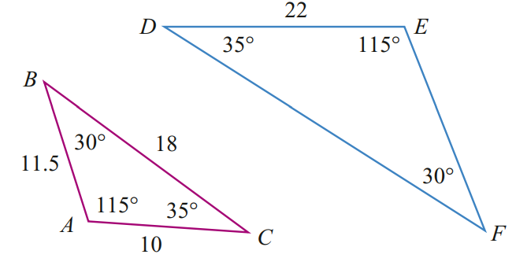
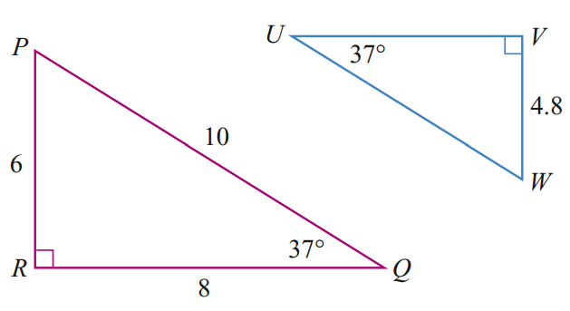
$ABC \sim$ ………  EFD  Scale factor:  2.2 | $RPQ \sim$ ………  VWU  Scale factor:  0.8
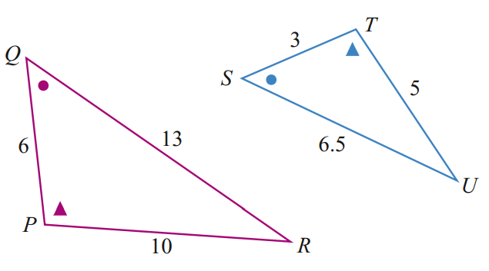
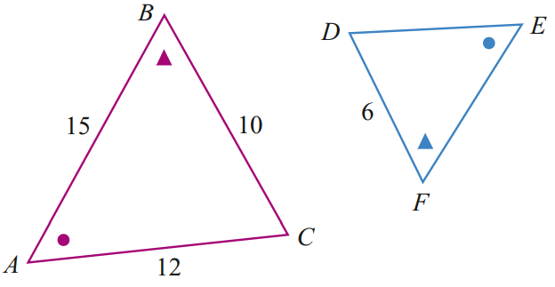
$ABC \sim$ ………  EFD  Scale factor:  0.6 | $PQR \sim$ ………  SUT  Scale factor:  0.5

- Determine the scale factor of the following pairs of similar figures.
It is helpful to redraw as two separate diagrams.
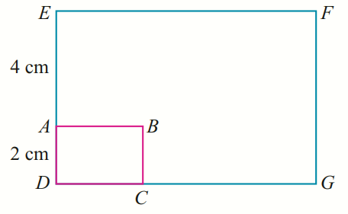  Original Image  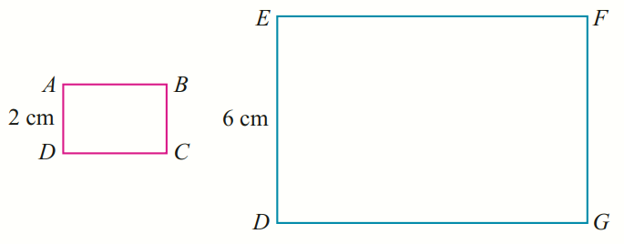  3 | 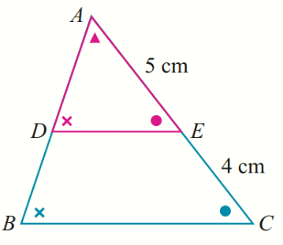  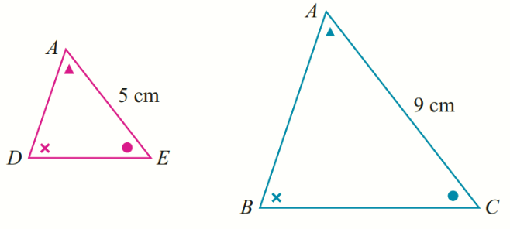  Original Image  1.8

Mastery
- Determine the scale factor for each case. You may need to redraw as two separate diagrams.
The purple shape is the original, the blue shape is the image.
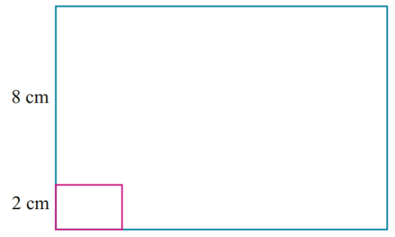  5 | 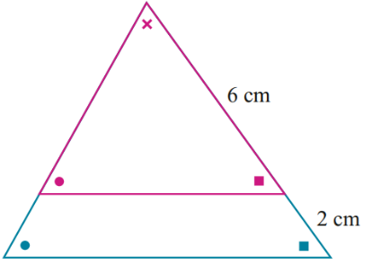  $$\frac{4}{3}$$
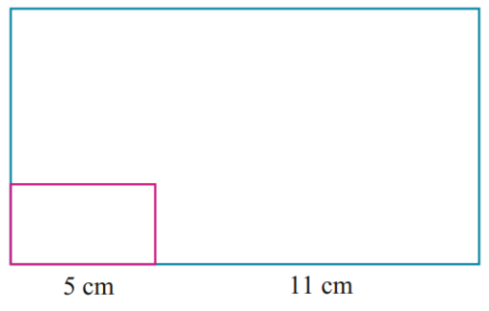  3.2 | 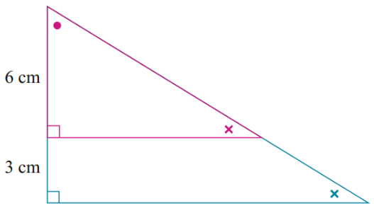  1.5
- A photograph 129 mm by 90 mm is enlarged to 172 mm by 120 mm.
What is the scale factor?

$$\frac{4}{3}$$
- A photo is projected onto a screen.
If the height of the photo is 10 cm and the height of its image on the screen is 1.2 m,
what is the scale factor?

12
- An A4 sheet of paper is 210 mm by 297 mm. An A3 sheet of paper is 297 mm by 420 mm.
What is the scale factor from A4 to A3, correct to two decimal places?

1.41

Calculate Sides by Finding Scale Factor First

- Calculating Missing Sides by Finding Scale Factor First
- Identify corresponding sides.
- Set up a ratio table original : image with corresponding sides for each row:
$$\underset{→}{× scale factor}$$
Original | $$:$$ | Image
Side 1 | $$:$$ | Side 1
Side 2 | $$:$$ | Side 2
$$\underset{←}{÷ scale factor}$$
- Calculate scale factor using $\frac{image}{original}$.
- Find unknown sides by multiplying or dividing by the scale factor.

- Example Calculate unknown sides given the scale factor
Find $x$ and $y$ in these similar figures
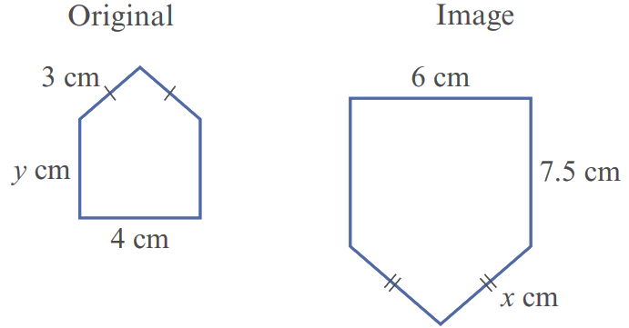
Original Image

1. Identify corresponding sides | 2. Set up ratio table
  Original | $$:$$ | Image
  $$4$$ | : | $$6$$
  $$3$$ | $$:$$ | $$x$$
  $$y$$ | $$:$$ | $$7.5$$
3. Calculate scale factor  $$Scale Factor= \frac{Image}{Original}=\frac{6}{4}=1.5$$ | 4. Find unknowns  $$\overset{←}{÷1.5}$$  $x=4.5$ cm $y=5$ cm
  Original | $$:$$ | Image
  $$4$$ | :  $$\underset{→}{×1.5}$$ | $$6$$
  $$3$$ | $$:$$ | $$4.5$$
  $$5$$ | $$:$$ | $$7.5$$
When setting up the ratio table, the rows must be pairs of ………………… sides.
We had to use 6 and 4 because they are the only pair of ………………… sides where the lengths are both given.
To find the image, we ………………; To find the original, we …………………
- Guided Practice
These figures are similar. Find the value of $x$and $y$.
- Original Image  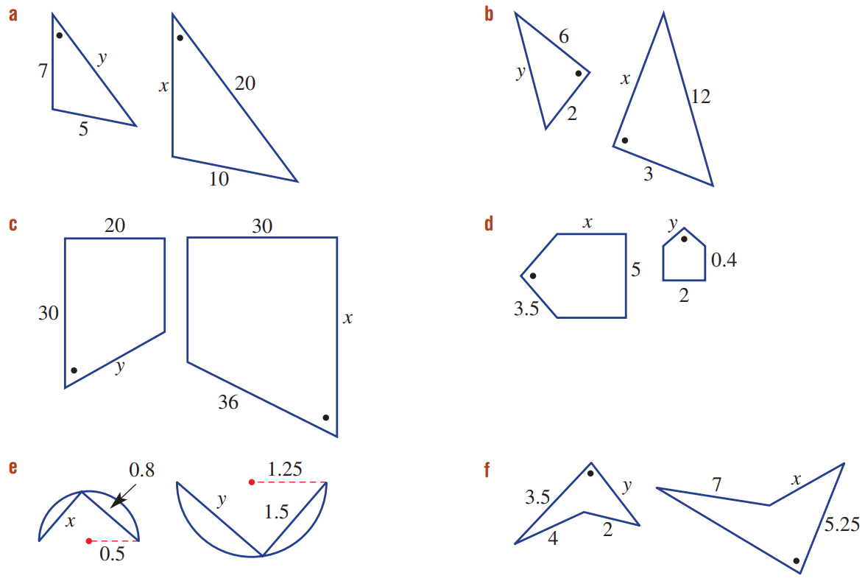  1. identify corresponding sides  2. set up ratio table  3. calculate scale factor  $$Scale Factor= \frac{Image}{Original}=$$  4. find unknowns  $$x=9, y=8$$ | - Original Image  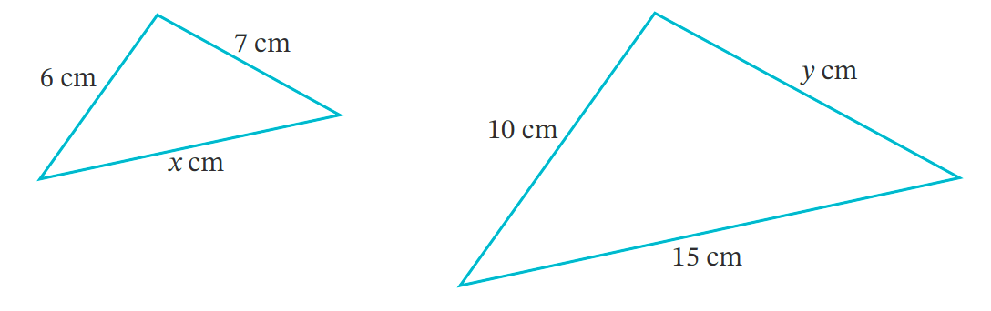  $$Scale Factor= \frac{Image}{Original}=$$  $$x=9, y=11.\dot{6}$$
  Original | $$:$$ | Image
  2 | $$:$$
  6 | $$:$$
  $$y$$ | :
  Original | $$:$$ | Image
   | $$:$$
   | $$:$$
   | :

Foundation
- Calculate the missing number.
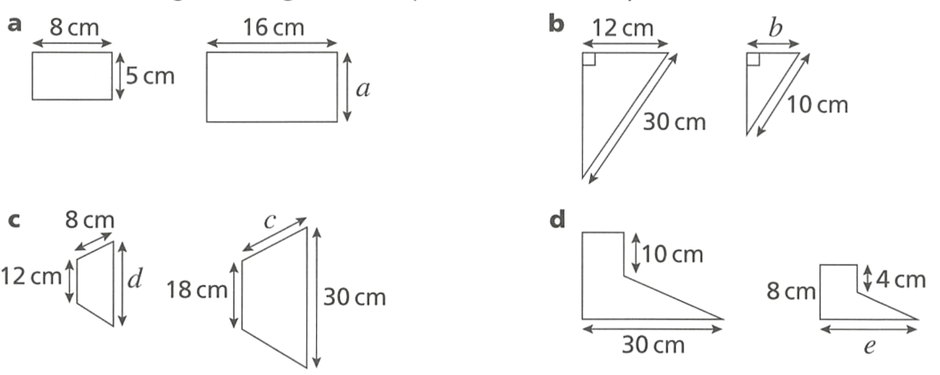  $$Scale Factor= \frac{Image}{Original}=$$  2  $a=$ $2×$ ……… $=$ …………  10 | $$Scale Factor= \frac{Image}{Original}=$$  $$\frac{1}{3}$$  $b=$ …………………………  4
  Original | $$:$$ | Image
  $$8$$ | : | $$12$$
  5 | $$:$$ | $$a$$
  Original | $$:$$ | Image
  $$30$$ | $$:$$ | $$10$$
   | :
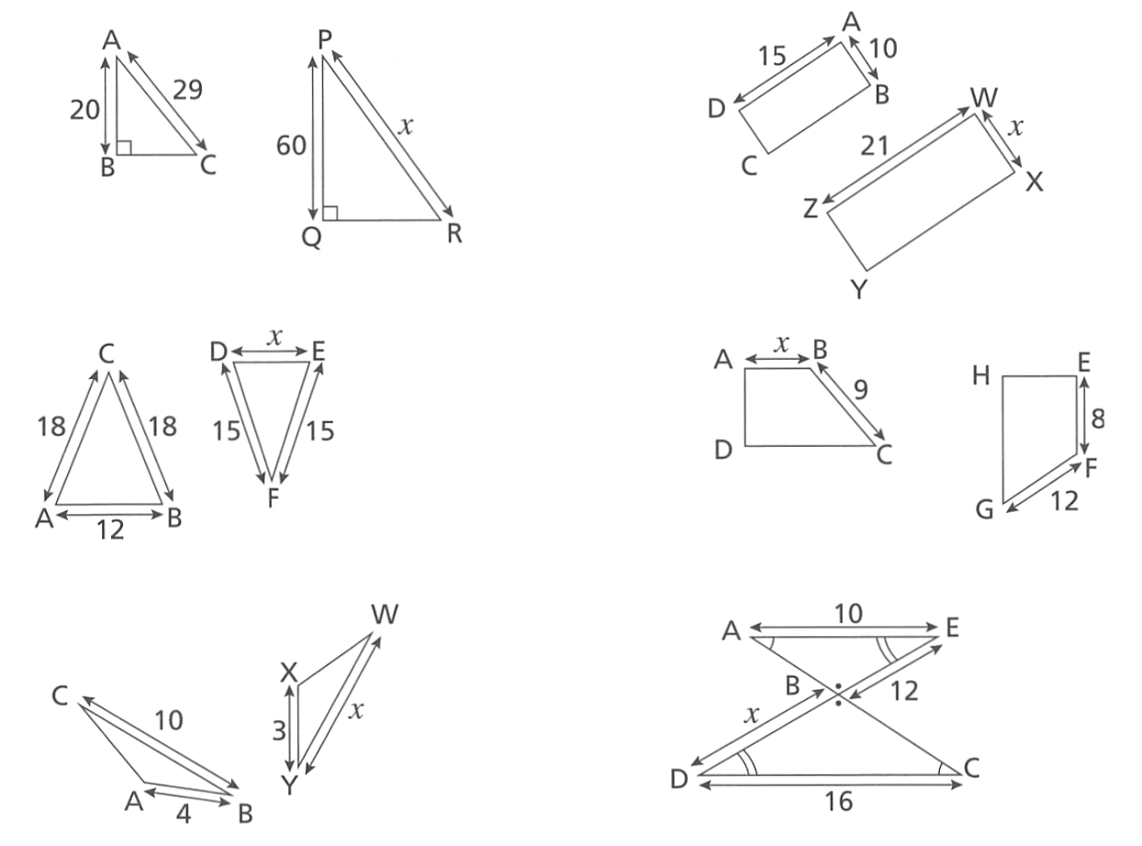  87 | 14
12 | 7.5
10 | 6
- Calculate the scale factor and then determine the unknown length.
$$Scale Factor= \frac{Image}{Original}=$$  1.5  $x=$ $6×$ ……… $=$ …………  9 | 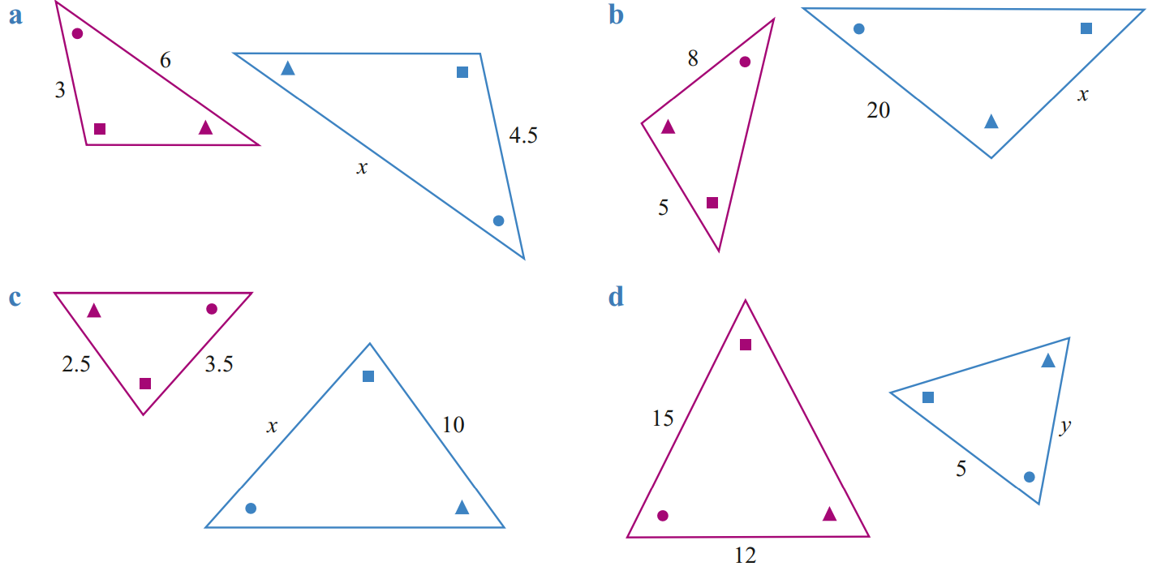  12.5
  Original | $$:$$ | Image
  $$3$$ | : | $$4.5$$
  6 | $$:$$ | $$x$$
  Original | $$:$$ | Image
  $$8$$ | $$:$$ | $$20$$
   | :
4 | 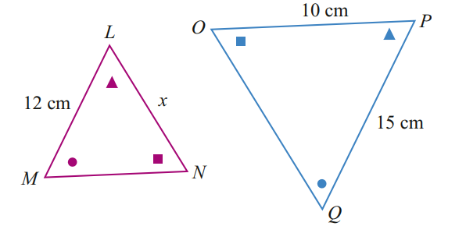  $Scale Factor=$  1.25  $x=$ $10÷$ ……… $=$ …………  8
  Original | $$:$$ | Image
  $$12$$ | : | $$15$$
  $$x$$ | $$:$$ | $$10$$
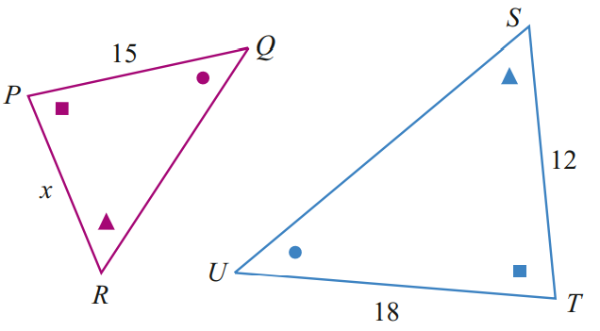  10 | 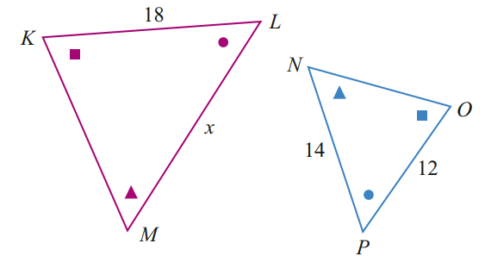  21
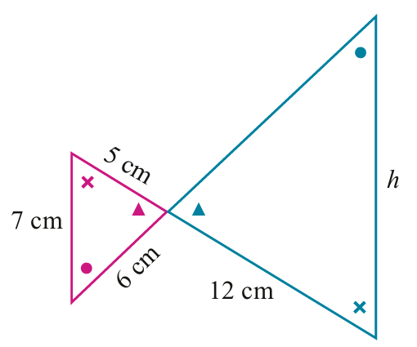  16.8 cm | 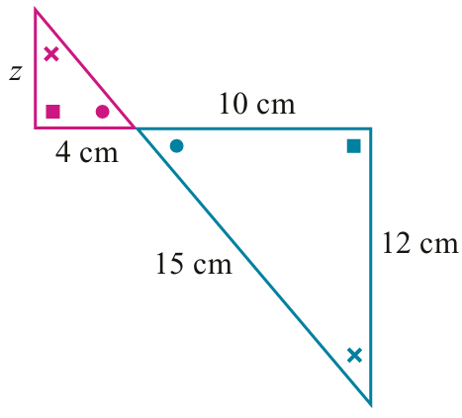  4.8 cm
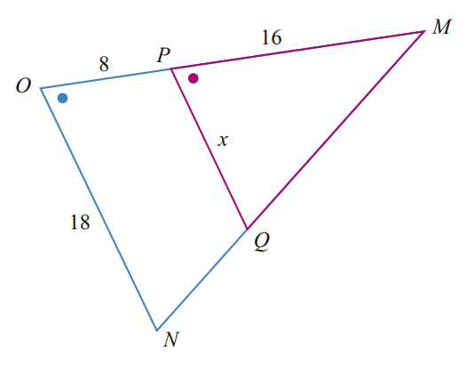  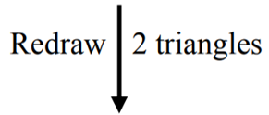  12 | 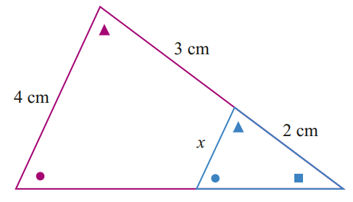  1.6 cm
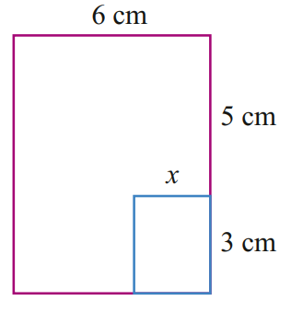  2.25 cm | 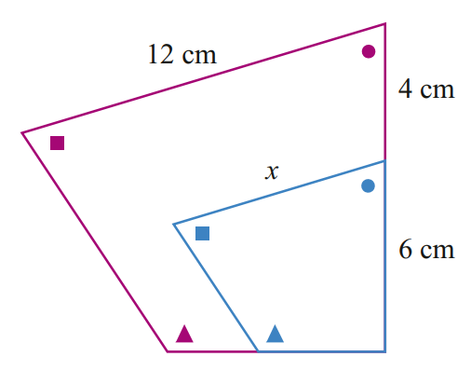  7.2 cm

Development
- Find the length of the unknown sides.
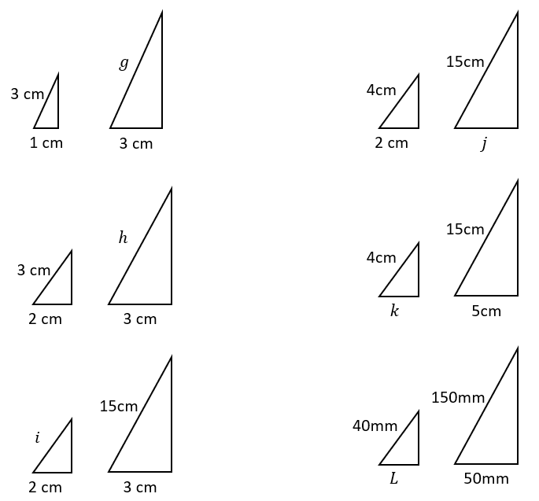  9 | 7.5
4.5 | $$1.\dot{3}$$
10 | $$13.\dot{3}$$

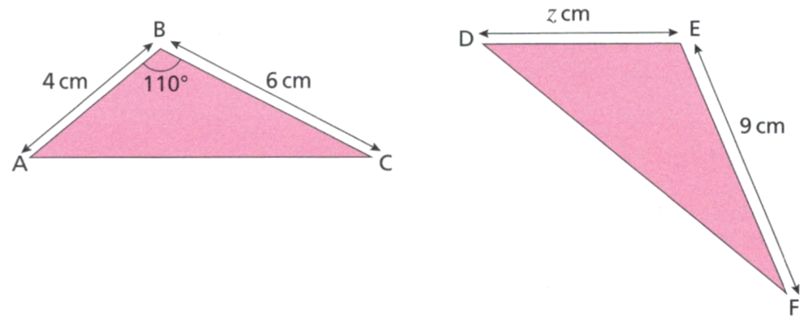
- These two triangles are similar.
  - What is the scale factor of enlargement from ABC to DEF?

1.5
  - Find the value of $z$

6 cm
  - What is the size of angle DEF? Why?

110°, as corresponding angles in similar figures are equal.
- Find the value of the missing sides.
$$x=14, y=10$$ | 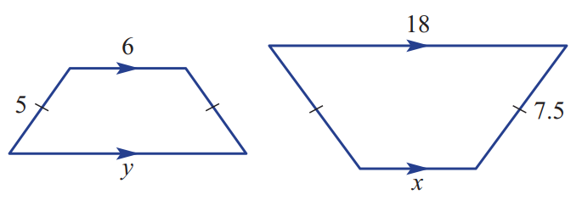  $$x=9, y=12$$
  Original | $$:$$ | Image
  5 | : | 10
  7 | $$:$$ | $$x$$
  $$y$$ | $$:$$ | 20
  Original | $$:$$ | Image
  5 | : | 7.5
   | $$:$$
   | $$:$$
$$x=45, y=24$$ | $$x=1, y=1.4$$
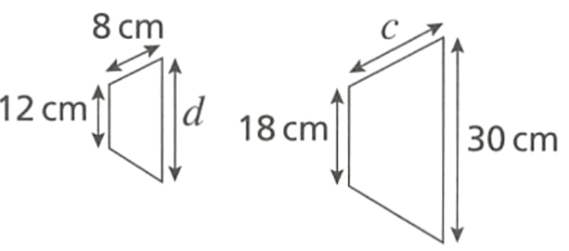  $$c=12, d=20$$ | $$x=19.2$$
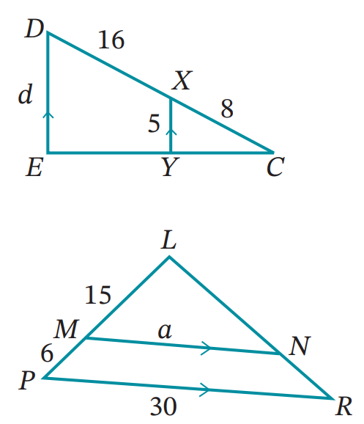  $$d=15$$ | $$a=21.43$$

Mastery
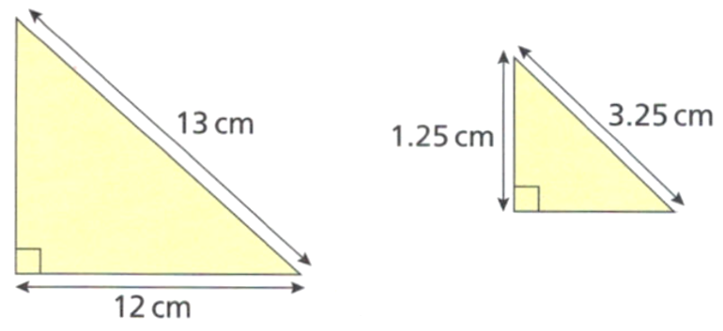
- Here are two similar right-angled triangles.
  - Find the missing lengths.

$5$ on left triangle and 3 on right triangle
  - Find the perimeter of each triangle.
Left: 30 cm, right: 7.5 cm
  - Is the ratio of the perimeters the same as the ratio of the sides? Why is this so?

Yes. Each side was scaled by the same amount, so the sum of all the sides is also scaled by the same amount.
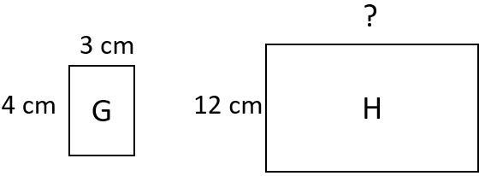
- Rectangles G and H are similar. Eva thinks the missing side length is 6.
Explain why she is incorrect.

She didn’t correctly identify the corresponding sides. The length should be 16 cm.
- Calculate the missing information for these two similar figures.
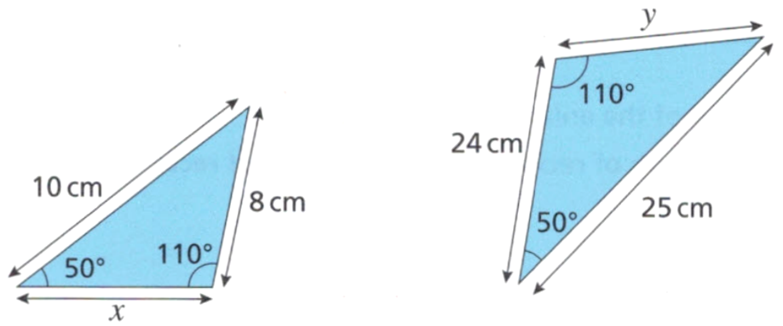  $$x=9.6, y=20$$ | 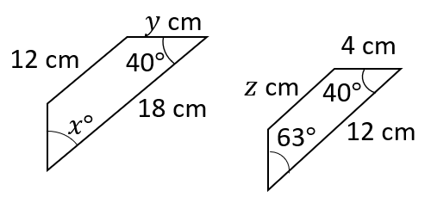  $$x=63°, y=6, z=8$$

- You can prove that two triangles are similar if all corresponding angles are equal.
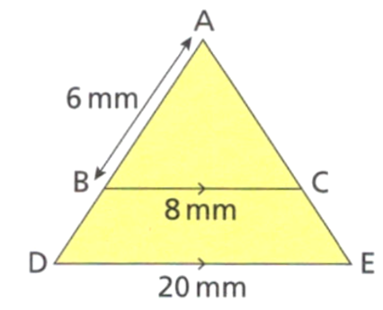
  - Using angle relationships, show that ABC and ADE are similar.

$∠ABC=∠ADE$ (corresponding angles on parallel lines)
$∠ACB=∠AED$ (corresponding angles on parallel lines)
$∠DAE$ is common
$∴$ $ΔABC$ is similar to $ΔADE$ (all corresponding angles are equal)
  - Find the length BD.

9 cm

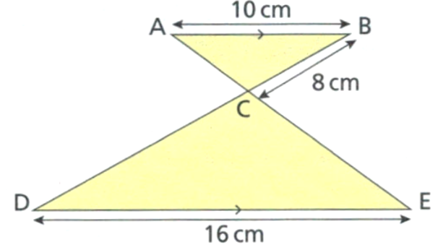
  - Using angle relationships, show that ABC and CDE are similar.

$∠ACB=∠DCE$ (vertically opposite)
$∠BAE=∠DEA$ (alternate angles on parallel lines)
$∠BDE=∠ABD$ (alternate angles on parallel lines)
$∴ΔABC$ is similar to $ΔADE$ (all corresponding angles are equal)

  - Four students have calculated the missing lengths. Here are their answers.

Which answer is correct? Show working to explain your answer.

`CD = 12.8 cm
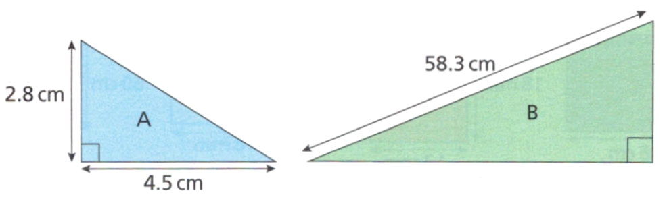
- These two triangles are similar. What is the perimeter of triangle B? (Hint: Pythagoras)

138.6 cm

Algebraic Fractions Method

- Algebraic Fractions Method for Similarity
- Corresponding sides of similar figures are in the same ratio:
$${\left(\frac{Image}{Original}\right)}_{matching sides}={\left(\frac{Image}{Original}\right)}_{matching sides}$$
$${\left(\frac{Original}{Image}\right)}_{matching sides}={\left(\frac{Original}{Image}\right)}_{matching sides}$$
- Always have the unknown in the numerator to make the equation easier to solve.

- Example Solve ratio problems using the algebraic fractions method
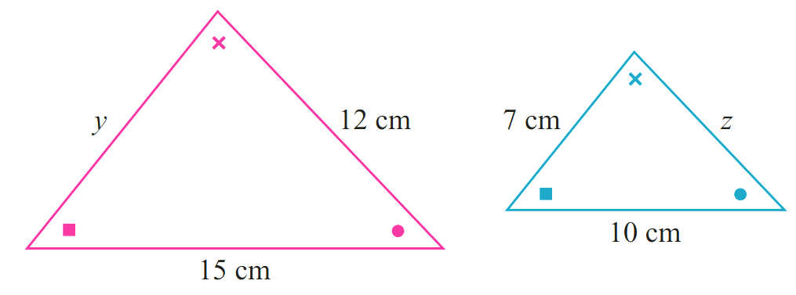

Finding $z:$$$\frac{z}{12}=\frac{10}{15} \\ ×12= ×12 \\ z=8$$ | Finding $y:$  $$\frac{y}{7}=\frac{15}{10}$$  $$×7= ×7 \\ y=10.5$$

- Guided Practice
Use the algebraic fractions method to determine the value of the pronumerals
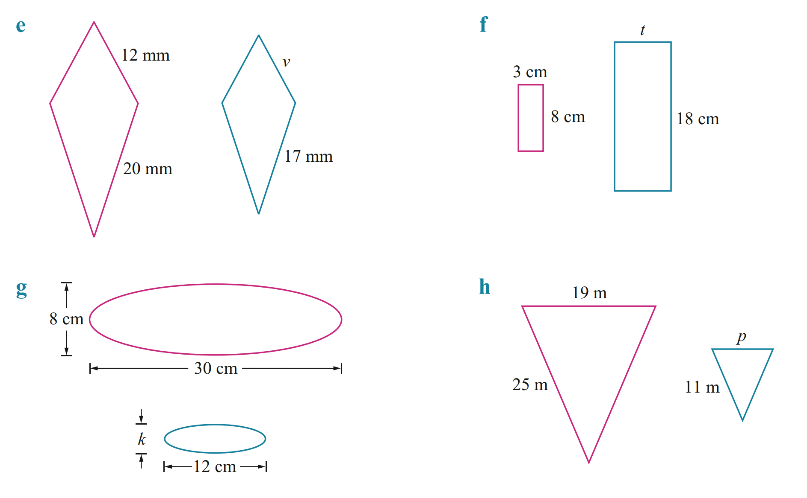  $$\frac{t}{3}=\frac{18}{8}$$  $t=6.75$cm | 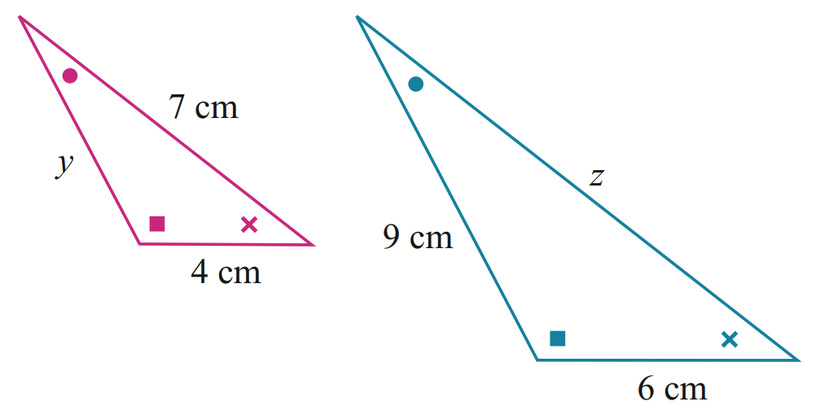
  $$\frac{z}{7}=\frac{}{}$$  $z=10.5$ cm | $$\frac{y}{}=\frac{}{}$$  $y=6$ cm

Foundation
- Use the algebraic fractions method to find the unknown values.
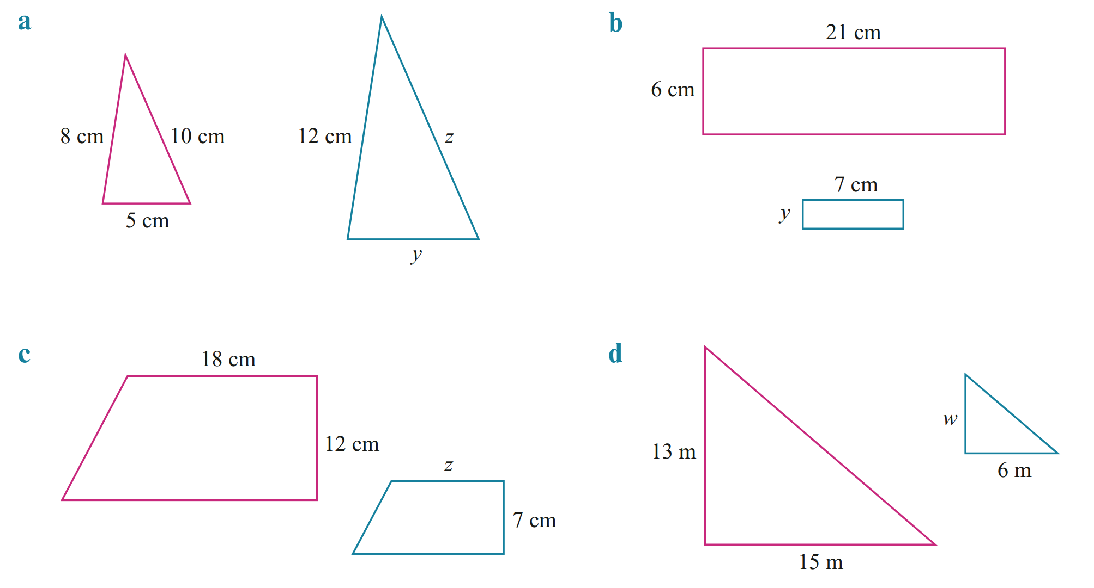  $$\frac{y}{6}=\frac{}{}$$  2 cm | 10.5 cm
5.2 cm | 10.2 cm
3.2 cm | 8.36 cm
$y=10$ m, $z=13.2$ m | 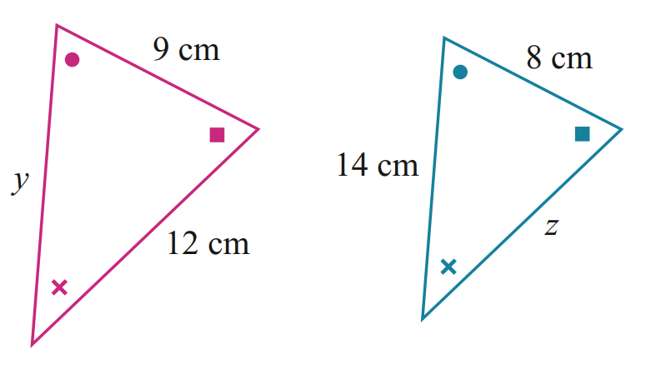  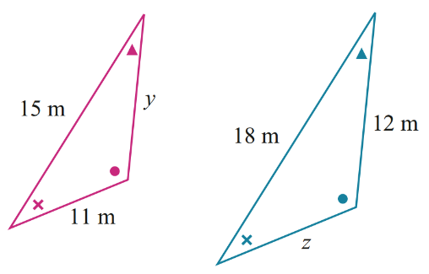  $y=15.75$ cm, $z=10.7$cm

Development
- Determine the value of the pronumeral. Careful, as these triangles are not oriented the same.
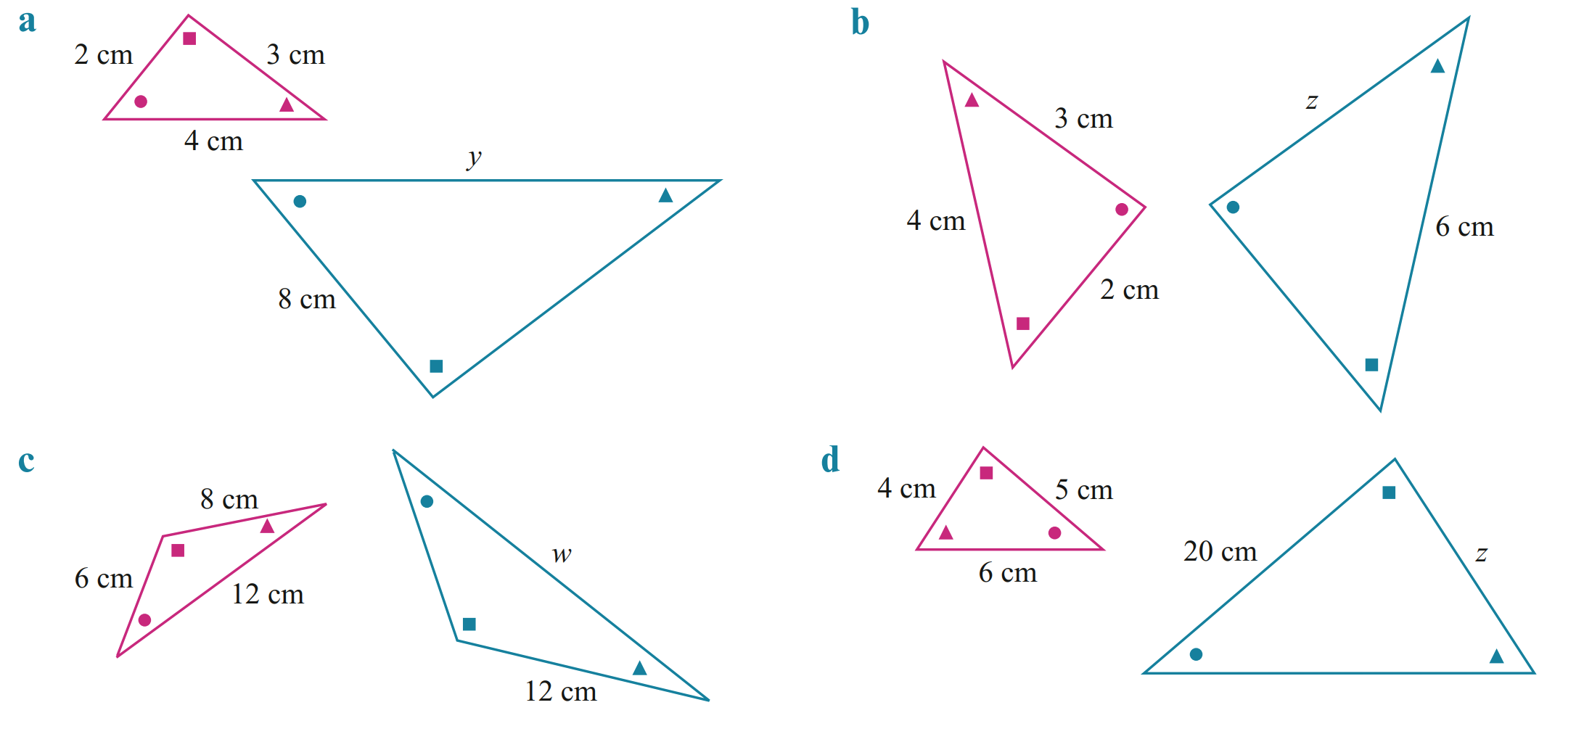  16 cm | 4.5 cm
18 cm | 16 cm
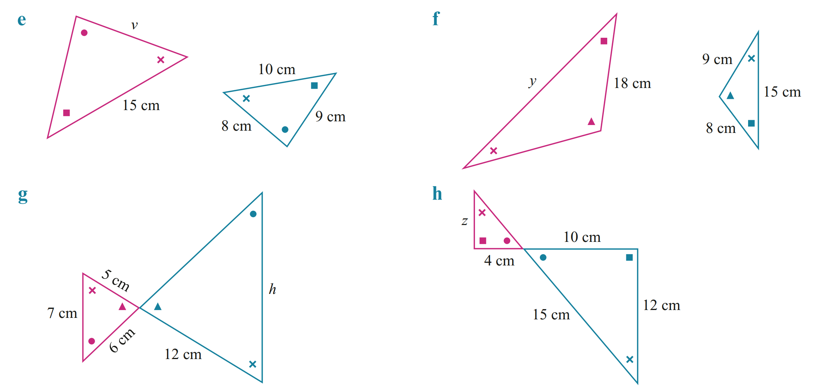  12 cm | 33.75 cm
16.8 cm | 4.8 cm

Mastery
- Find the value of $x$ in each of these triangles.
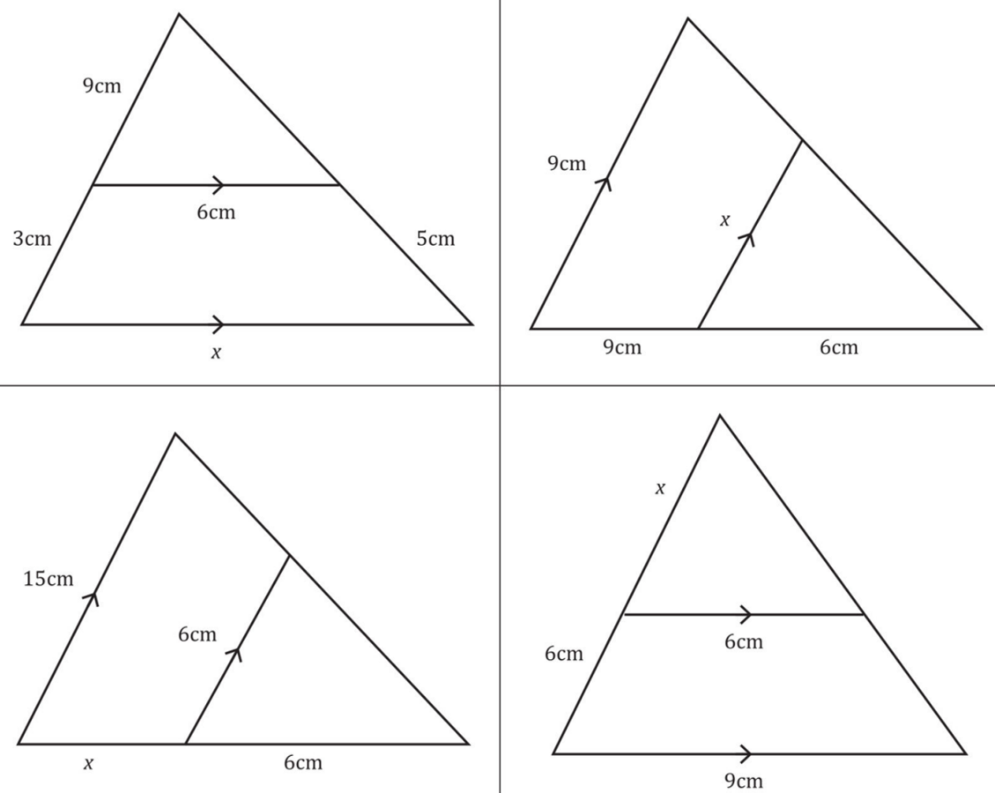  8 cm | 3.6 cm
9 cm | 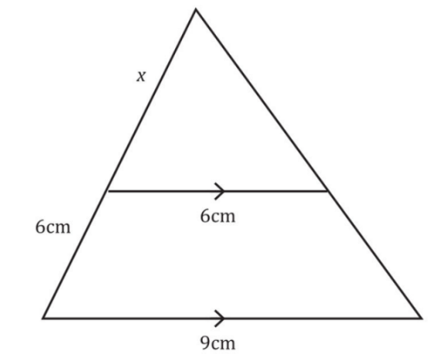  12 cm

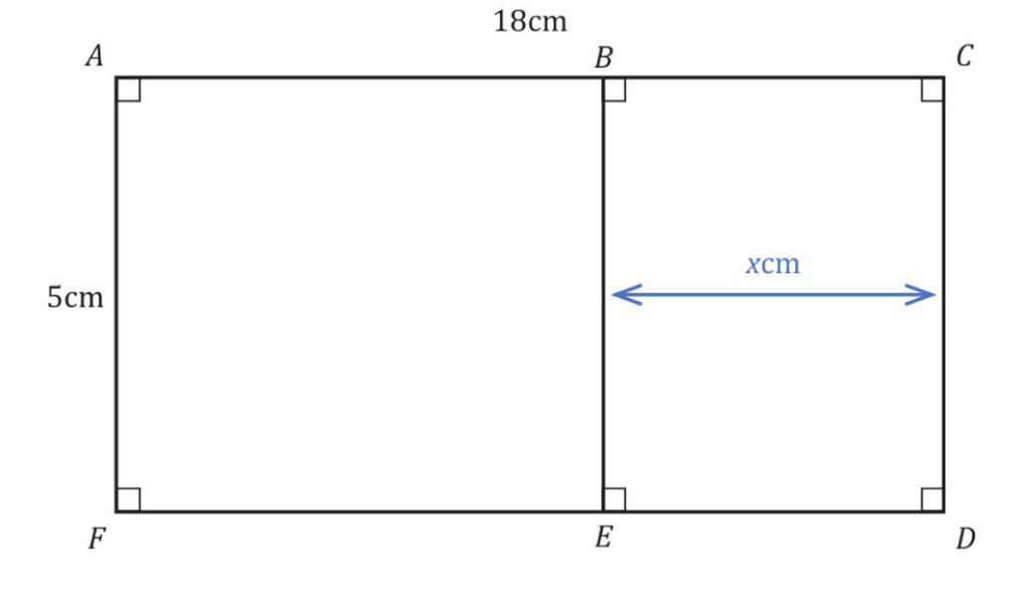
- Rectangles ACDF and EBCD are similar. Find the value of $x$.

$x=$ $\frac{25}{18}$ cm
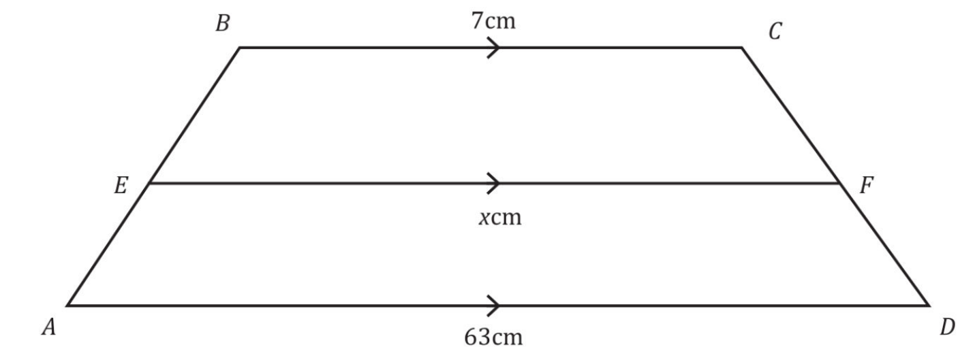
- Trapezia BCFE and EFDA are similar. Find the value of $x$.

21 cm

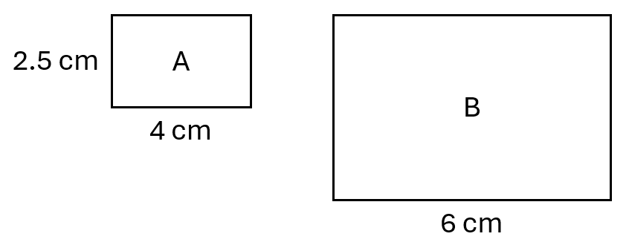  - These rectangles are similar.  Find the area of $B$.  22.5 cm² | - These rectangles are similar.  Find the length of rectangle $A$.  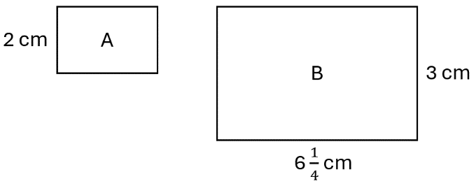  $$\frac{25}{6}$$

Similar Figure Problems

- Solving Problems involving Similar Lengths
- Set up ratio table.
- Calculate scale factor.
- Find unknown sides.

- Example Solve problems involving scale and similarity
Chris’ shadow is 1.2 m long and a 1 m vertical stick
has a shadow that is 0.8 m long. Determine Chris’ height.
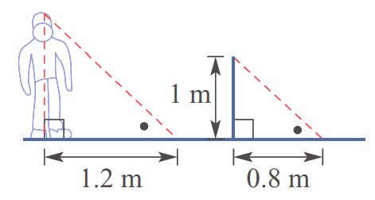

Ratio table method | Algebraic fraction method  $$\frac{x}{1}=\frac{1.2}{0.8} \\ x=1.5$$
  Original | $$:$$ | Image
  1.2 | $$:$$ | 0.8  $$\overset{←}{ ÷\frac{2}{3} }$$
  1.5 | $$:$$ | 1
Chris is 1.5 m tall.

- Guided Practice
A tree’s shadow is 20 m long and a 2 m vertical stick has a shadow that is 1 m long.
Find the height of the tree.
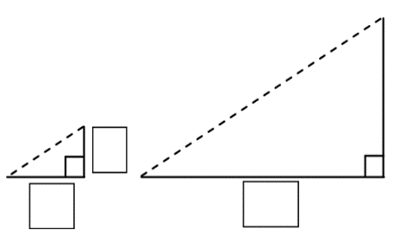
$h$

40 m

Foundation

- A 1 m high post casts a 2 m long shadow. How tall is the tree that casts an 8 m long shadow?  Original Image  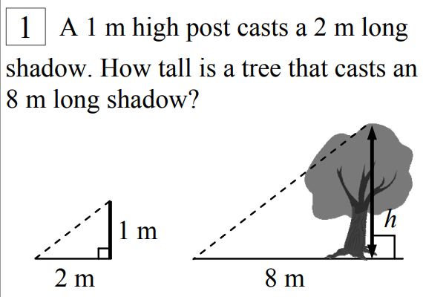  4 m | - Chris’ shadow is 1.2 m long and a 1 m vertical stick has a shadow that is 0.8 m long. Determine Chris’ height  1.5 m
- A 0.5 m high post casts a 2 m long shadow. How tall is the giraffe that casts a 22 m long shadow?  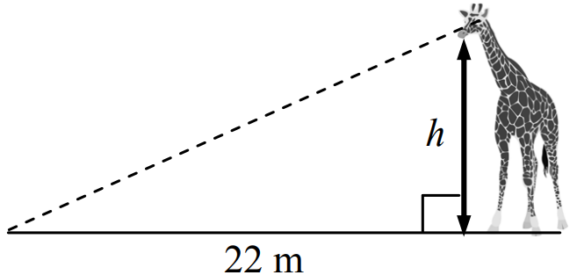  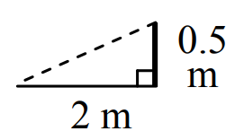  5.5 m | 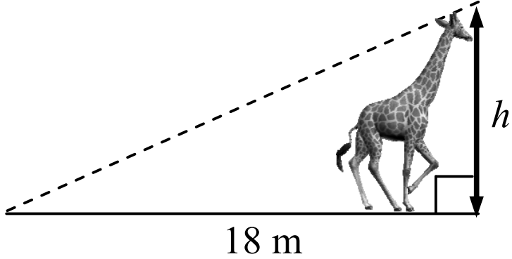  - How tall is the giraffe that casts a 18 m long shadow?  4.5 m
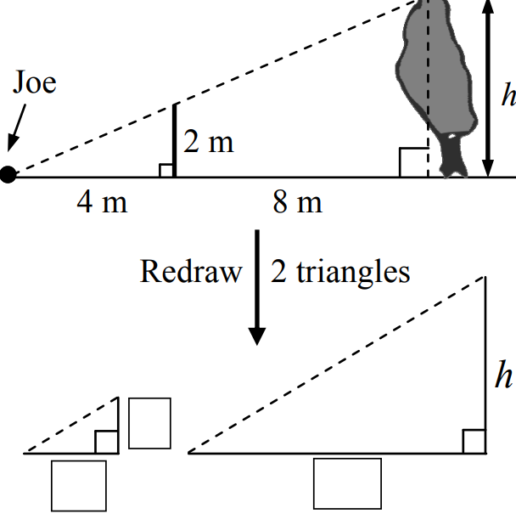  6 m | 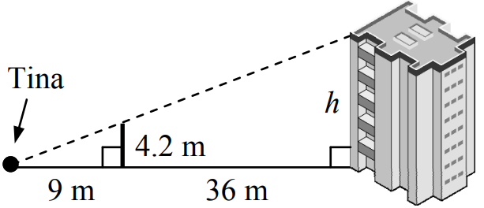  21 m
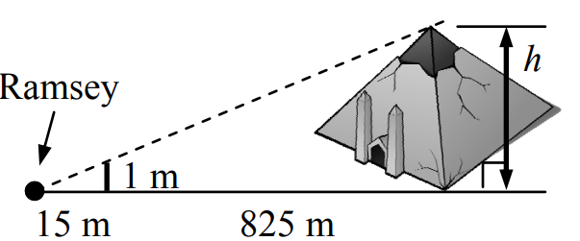  56 m | 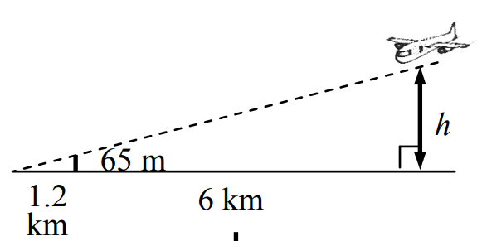  0.39 km

Development
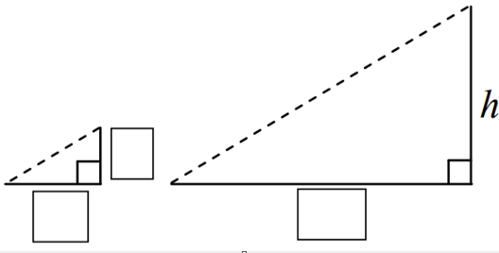
- On a bright sunny day the shadow cast by a flagpole is 12 m long.
At the same time the shadow cast by a 1 m ruler is 2 m long. Find the height of the flagpole.

6 m
- 2022 HSC Standard 1
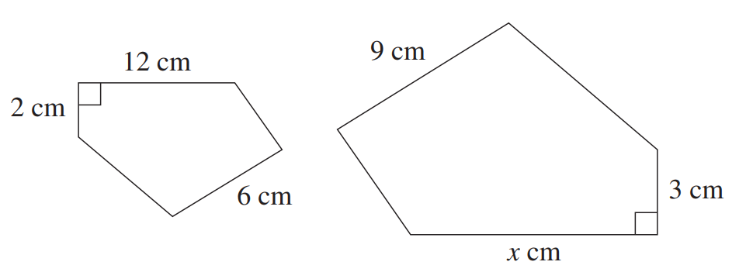
Two similar figures are shown. What is the value of $x$?

18 cm
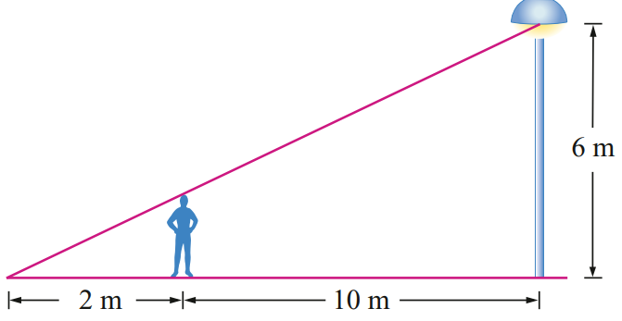
- A light pole has a globe that is 6 m above the ground. How tall is a boy who casts a 2 m long shadow when standing 10 m from the base of the pole?

1 m tall
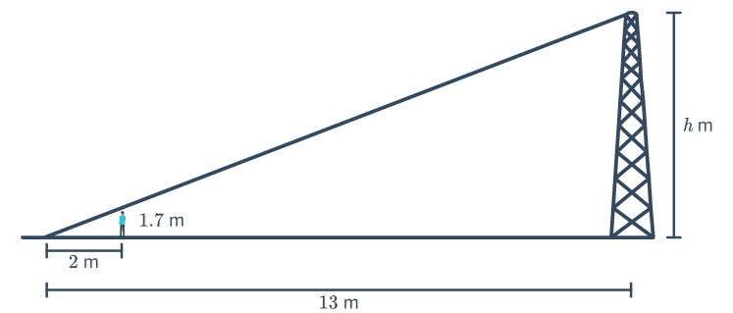
- James is 1.7 m tall and casts a shadow 2 m long. At the same time, a tower casts a shadow 13 m long. If the tower is h metres high, solve for h.

11.05 m
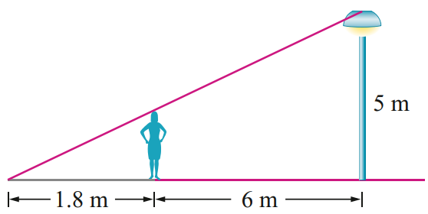
- A street lamp is 5 m high. When a girl stands 6 m from the base of the lamp her shadow is 1.8 m long. Calculate the height of the girl, to the nearest centimetre.

115 cm

Mastery
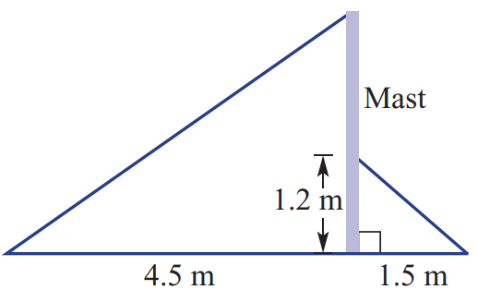
- Two similar triangles are created by cables supporting a yacht's mast.
Solve for h, the height of the mast.

3.6 m
- Two cables support a pole at the same angle, as shown.
The two cables are 4 m and 10 m in length. The shorter cable reaches 3 m up the pole.
Find the height of the pole.
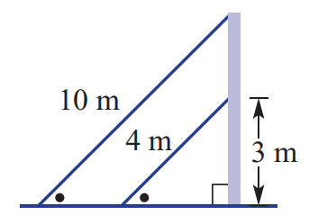

7.5 m
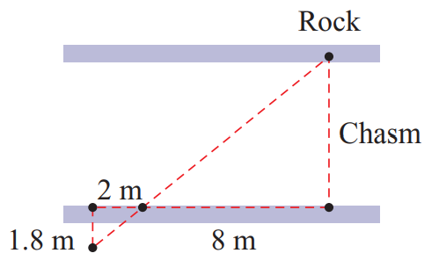
- A deep chasm has a large rock sitting on its side.
Four pegs are placed on the other side using the rock as a reference point.
Find the width of the chasm.

7.2 m
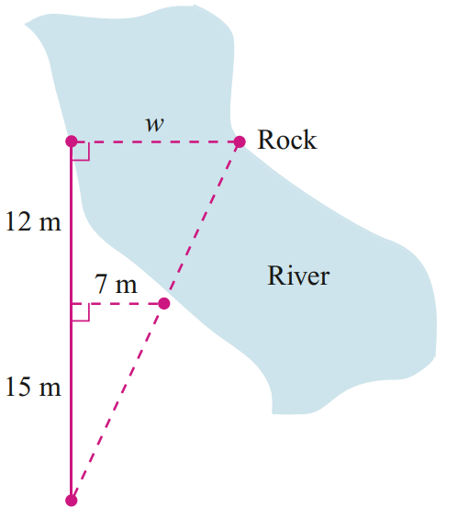
- Determine the width of the river.

12.6 m

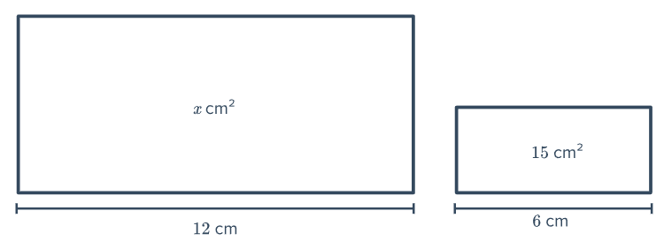
- Determine the area of the scaled rectangle.

60 m²
- 2012 HSC Standard 2 Band 5
Jacques and a flagpole both cast shadows on the ground.
The difference between the lengths of their shadows is 3 metres.
What is the value of $d$, the length of Jacques’ shadow?
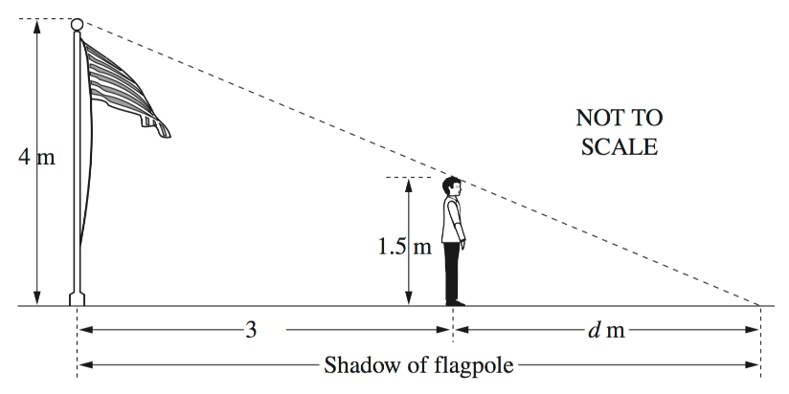

1.8 m
- 2021 HSC Standard 2 Band 5
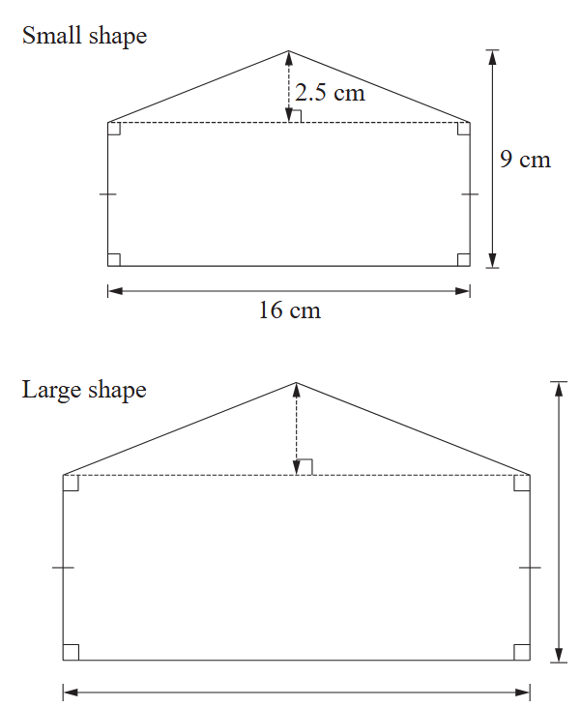
The diagrams show two similar shapes.
The scale factor is 1.5. Calculate the area of the large shape.

279 cm²
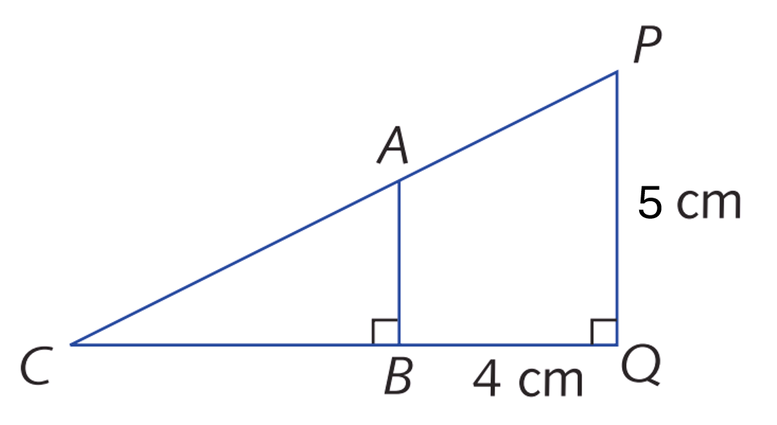
- Determine the scale factor for these similar triangles if $AB$ is half the length of $BC$.
Let $ΔABC$ be the original triangle.

Scale factor is $\frac{5}{3}$

Finding Lengths in Scale Drawings

- Scale Drawings
A scale drawing is a smaller or larger drawing of a real-life object.
Examples include maps, house plans, and scientific diagrams.
We call the real-life object the original, and the drawing the image.
Scales for scale drawings are written in simplified ratio notation:

$$image :original \\ 1 : n$$

A scale of 1:500 means every 1 unit on the drawing is 500 units in real life.
- Notice that the ratio is reversed; image : original instead of original : image
- Set up a ratio table image : original
  - The first row should be the given scale.
  - The second row should be the given length and the length you want to find.
- Find the unknown side by multiplying or dividing.

- Example Calculate original length using a ratio scale
A map has a scale of $1:500$.
What is the real-life distance that 28 mm on the map would represent?
1. Ratio table | 2. Find unknown  $$\underset{→}{×500}$$  The real-life distance is 14 000 mm, or 14 m.
  Image | $$:$$ | Original
  1 | $$:$$ | 500
  28 | $$:$$
  Image | $$:$$ | Original
  1 | $$:$$ | 500
  28 | $$:$$ | 14 000

- Guided Practice
- A map has a scale of $1:1000$.  What is the real-life distance that  37 mm on the map would represent?  37 000 mm or 37 m | - A city map has a scale of $1:10 000$.  If the distance between two landmarks on the map is 3 cm, what is the real-life distance between the landmarks?  30 000 cm or 300 m
  Image | $$:$$ | Original
   | $$:$$
   | $$:$$
  Image | $$:$$ | Original
   | $$:$$
   | $$:$$
- Example Calculate image length using a ratio scale
A map has a scale of $1:500$.
What length on the map would represent 85 m in real life?
1. Ratio table | 2. Find unknown  $$\overset{←}{÷500}$$  The map distance is 0.17 m, or 17 cm.
  Image | $$:$$ | Original
  1 | $$:$$ | 500
   | $$:$$ | 85
  Image | $$:$$ | Original
  1 | $$:$$ | 500
  0.17 | $$:$$ | 85

- Guided Practice
- A diagram has a scale of $1:200$.  What length on the diagram represents 450 metres in real life?  Answer in metres.  2.25 m | - A map has a scale of $1:10 000$.  What length on the map would represent 23 km in real life?  Answer in metres.  2.3 m
  Image | $$:$$ | Original
   | $$:$$
   | $$:$$
  Image | $$:$$ | Original
   | $$:$$
   | $$:$$
- A scientific poster shows a flea at a scale of 50 : 1. If the flea is 6 mm in length in real life, how large should it be on the poster, in centimetres?  30 cm | - A map has a scale of 1 : 500 000.  Two cities are 50 km apart in real life, how far apart are they on the map, in centimetres?  10 cm
  Image | $$:$$ | Original
   | $$:$$
   | $$:$$
  Image | $$:$$ | Original
   | $$:$$
   | $$:$$

Foundation
- A map has a scale of 1:50 000.
  - How many centimetres in real life does 1 cm on the map equal?
50 000 cm
  - Therefore, how many metres does 1 cm represent?
500 m
  - What is the scale factor, as a fraction?
$$\frac{1}{50000}$$

- A map scale is given as 1 cm = 100 m. Write this as a simplified ratio.

$$1:10 000$$

- A map has a scale of 1:100.  How many metres on the map does  300 m in real life equal?  3 m | - Your science teacher tells you to draw a scale drawing of a tree with scale 1:150.  If the tree is 45 m high, how high should it be in your drawing?  0.3 m or 30 cm
  Image | $$:$$ | Original
   | $$:$$
   | $$:$$
  Image | $$:$$ | Original
   | $$:$$
   | $$:$$
- A map scale is 1:200 000.  Chatswood to Redfern is 4 cm on the map. How far is it in real life?  8 km | - Blackbottle and Toowoola are 17 cm apart on a map with a scale of 1:50 000.  How many km apart are the towns in real life?  8.5 km
- The town of Gilgandra is 66 km north of Dubbo. On a map with a scale of  1 : 100 000, what is the scaled distance between the 2 towns?  66 cm | - Lord Howe Island is 2.8 km wide.  How long would its scaled width be on a map with a scale of 1 : 50 000?  5.6 cm

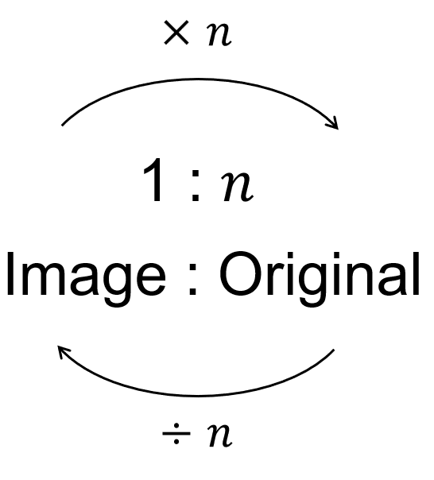
A shortcut you can use only if scale factor is given in the form $1:n$ or $n:1$

- Find the actual distance for the given scaled distances.
Give your answer in an appropriate unit.
- 1: 5 | i 44 m  $44 m×5=$ …………  220 m | ii 310 cm  1550 cm
- 1: 10 000 | i 2 cm  200 m | ii 4 mm  40 m
- 1: 20 000 | i 80 cm  16 km | ii 18.5 mm  370 m
- 1: 400 | i 16 mm  6.4 m | ii 0.03 m  12 m
- 1: 0.5 | i 12 cm  6 cm | ii 3.2 mm  1.6 mm
- 100: 1 | i 3 cm  0.03 cm | ii 11.5 km  115 m

- Find the scaled length for the given actual lengths.
- 1: 10 | i 40 m  $40 m÷10=$ …………  4 m | ii 310 cm  31 cm
- 1: 200 | i 200 m  1 m | ii 4 km  20 m
- 1: 500 | i 10 000 m  20 m | ii 75 cm  0.15 cm
- 1: 10 000 | i 1350 m  0.135 m | ii 45 km  4.5 m
- 1: 0.1 | i 23 m  230 m | ii 6.15 m  61.5 m
- 100: 1 | i 7.5 cm  750 cm | ii 8.2 m  820 m

Development

- Scale $1:500$. An image length is 3 cm.  Find the original length in metres.  15 m | - Scale $1:500$. An original length is 20 m.  Find the image length in centimetres.  4 cm
- Scale $1:25 000$. A map distance is 6 cm.  Find the original distance in kilometres.  1.5 km | - Scale $1:25 000$. Two places are 3 km apart.  Find their map distance in centimetres.  12 cm
- Scale $50:1$. An object is 8 mm long.  Find the image length in centimetres.  40 cm | - Scale $50:1$. An image is 30 cm long.  Find the original length in millimetres.  6 mm
- Scale $1:200$. A drawing length is 45 mm.  Find the original length in metres.  9 m | - Scale $1:200$. An original length is 7.2 m.  Find the drawing length in centimetres.  3.6 cm
- A cell is 0.012 mm long and is drawn at $500:1$.
Find the drawing length in millimetres.

6 mm

- A map scale is a ratio of scaled distance : real-life distance.
A map of a park was drawn using the scale ratio of 1 : 500.
  - 1 mm on the map represents ………… mm in real life.
500
  - 1 cm on the map represents ………… cm in real life.
500
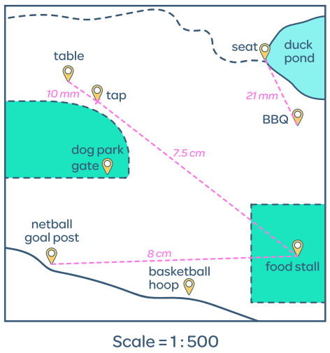
  - Calculate the real-life distance between the table and the tap:
Scaled | : | Real Life
1 | : | 500
10 | :

5000 cm
  - Convert your answer to metres: …………… m
50 m
  - Calculate the distance between the seat and
the BBQ in metres.

10.5 m
  - Calculate the real-life distance between the netball goal post and the food stall in metres.

40 m
  - In real life, the distance between the dog park and the food stall is 35 000 mm.
How far would it be on the map?

7 cm
- A model city has a scale ratio of 1 : 1000.
- Find the real-life height of a skyscraper that has a scaled height of 8 cm.  80 m | - Find the scaled length of a train platform that is 45 m long in real life.  4.5 cm
  Scaled | : | Real Life
   | :
   | :
  Scaled | : | Real Life
   | :
   | :
- A scientist draws a bacteria using the scale 100:1.
If the drawing is 7 cm long, how long is the bacteria in real life?
Scaled | : | Real Life
100 | : | 1
 | :
0.07 cm
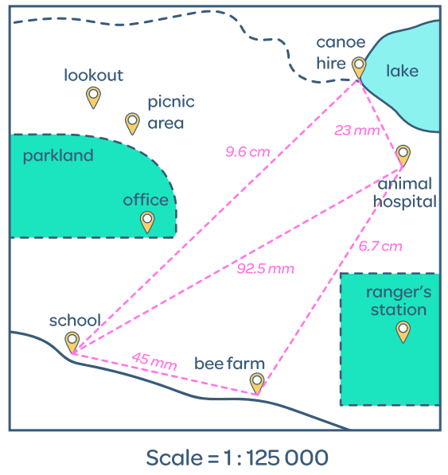
- A map is drawn with a scale of 1:125 000.
  - 1 mm on the map represents:
……………… mm in real life.
125 000
……………… cm in real life.
12 500
……………… m in real life.
125
……………… km in real life.
0.125
  - A teacher is planning a class excursion from the school to the bee farm.
What is the real-life distance between the two locations?

5.625 km
  - Between the office and the ranger station the real-life distance is 7 km.
How far apart would they be on the map?

56 mm

Mastery
- A map maker wants to make a map of an area that is 8 km by 8 km.
She decides to use a scale of 1:100. Explain why this map scale is not appropriate.

A 1:100 scale would make the 8 km × 8 km map 80 meters × 80 meters, which is impractically large for any practical use
- A scientist shows a photomicrograph image of a 10 cm long cell.
He says the cell is magnified by a scale of 1:100 000 through his microscope.
Explain what is wrong with the scientist’s ratio.

The scientist's ratio is backwards - a magnification should be written as 100,000:1, not 1:100,000, since the image is larger than the actual cell.
- An engineer designs a mobile phone SIM card using a diagram with a scale of 100:1.
If the scaled drawing is 80 cm long, what is its actual length in millimetres?

8 mm
- Your science teacher asks you to draw a scale diagram of a bacteria cell with a scale of 500:1
If the microscope says the bacteria is 0.01 mm in length, how long should the bacteria in your diagram be?

5 mm

- 2012 HSC Standard 2 Band 5
A map has a scale of 1 : 500 000.
Two mountain peaks are 2 cm apart on the map.
What is the actual distance between the two mountain peaks, in kilometres?

10 km
Two cities are 75 km apart. How far apart are the two cities on the map, in centimetres?

15 cm
- 2021 HSC Standard 2 Band 5
A rectangular sportsground has been drawn to scale on a 1-cm grid as shown.
The scale used is 1: 3000
Kerry took 12 minutes to walk around the perimeter of this sportsground.
What was Kerry's average speed in kilometres per hour?
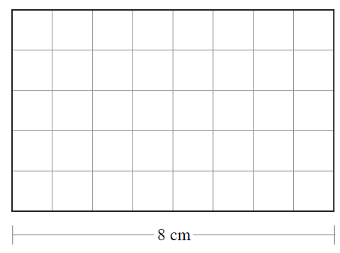

3.9 km/h

Calculating Scale Factor in Scale Drawings

- Scale Factor
$$\frac{Image}{Original}=image :original$$

- Identify image (scale drawing) and original (real life).
- Convert units to be the same.
- Calculate scale factor using $\frac{image}{original}$
- Rewrite scale factor in ratio notation.

- Example Success Criteria
Drawing Real Life    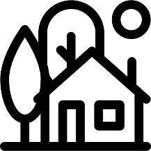  50 cm 150 m  1. image original  2. 50 15 000  3. scale factor $=$ $\frac{50}{15000}$ $=$ $\frac{1}{300}$  4. scale factor $=1:300$ | We changed 150 to 15 000 because ratios always compare the same ……………  The scale factor is $\frac{50}{15000}$ because scale factor as a fraction is …………… divided by ………………  $\frac{1}{300}$ $=1:300$because a fraction written as a ratio is ………………… : ……………………

- Guided Practice
Calculate the scale factor if:
- the length on the drawing is 32 cm and represents 1600 m in real life.  1. image = original =  2. scale factor $=$ $\frac{image}{original}$ $=$  3. scale factor = 1 : ……  1:5000 | - 1.5 kilometres in real life is represented by 60 cm on a blueprint.  1.  2.  3.  1:2500

- Key Ideas
- Scale drawings are ……………… figures of real-life objects.
- Scale factor for scale drawings are written in ratio notation …………… : ……………

Foundation
- Convert the two measurements provided in each scale into the same unit, and then write the scale as a ratio of two numbers in simplest form.
- 2 cm : 200 m  $=2$ cm : 20 000 cm  $= 1 :$ ……………  1:10 000 | - 5 mm : 500 cm  1:1000 | - 12 mm : 360 cm  1:300
- 4 mm : 600 m  1:150 000 | - 4 cm : 5 m  1:125 | - 1 cm : 2 km  1:200 000
- 28 mm : 2800 m  1:100 000 | - 3 cm : 0.6 mm  50:1 | - 1.1 m : 0.11 mm  10 000:1

- Calculate the scale factor for each of the following. Reminder to convert all units to the same.
- 2 cm on a scale drawing represents an actual distance of 50 cm.  1:25 | - 4 cm on a scale drawing represents an actual distance of 2 km.  1:50 000
- 1.2 cm on a scale drawing represents an actual distance of 0.6 km.  1:50 000 | - 5 cm on a scale drawing represents an actual distance of 900 m.  1:18 000
- An actual length of 7 mm is represented by 4.9 cm on a scaled drawing.  7:1 | - An actual length of 0.2 mm is represented by 12 cm on a scaled drawing.  600:1

- A scaled length of 5.5 cm is equal to 44 km in real life.
  - How many kilometres does a scaled length of 3 cm equal?
24 km
  - How many kilometres does a scaled length of 20 cm equal?
160 km
  - How many centimetres does an actual distance of 100 km equal?
12.5 cm

Development
- Complete the table. Answer in the most appropriate unit.
Scale Factor  Image : Original | Image Length | Original Length
1 : 10 000 | 0.9 m | 9 km
1 : 10 000 | 9 cm | 900 m
1 : 10 000 | 18 cm | 1800 m
1 : 5000 | 36 cm | 1.8 km
1 : 5000 | 72 cm | 3600 m
1 : 5000 | 35 mm | 175 m
1 : 5000 | 70 mm | 350 m
1 : 2500 | 70 mm | 175 m
1 : 2500 | 35 mm | 87.5 m
1: 100 000 | 52 cm | 52 km
1:1 000 000 | 52 cm | 520 km
1:500 000 | 104 cm | 520 km
1: 500 000 | 104 mm | 52 km

Mastery
- HSC Sample Question Band 5
On a map, the distance between two towns is measured at 54 millimetres.
The actual distance between the two towns is 16.2 kilometres. What is the scale of the map?

1:300 000
If two other towns on the same map are 9.2 centimetres apart, what is the actual distance between the two towns in kilometres?

27.6 km
- 2019 HSC Standard 2 Band 5
A map is drawn to scale, on 1-cm paper, showing the position of a supermarket and a cinema.
It takes 10 minutes to walk in a straight line from the cinema to the supermarket at a constant speed of 3 km/h. Show that the scale of the map is 1 cm = 100 m.
